A dissertation submitted to the University of Greenwich in partial fulfilment of the requirements for the Degree of

Master of Science

in

Computer Forensics and Cyber Security

AI-Driven SIEM Workflow Automation and Zero-Trust Endpoint Protection for Securing Cloud Supply Chains

Name: Muhammed Afnaan
Student ID: 001466352

Supervisor:Nagmeh, Moradpoor
Submission Date: September 2026
Word count: 15,210

Abstract

The rapid adoption of cloud computing has significantly transformed modern security operations centers and groundnuts by importing highly distributed infrastructures with increased volumes of security telemetry generated from endpoints, specifically cloud endpoints, authentication systems, and cloud services. All those security information and management platform tools, such as Elastic SIEM and Splunk, provide essential capabilities for monitoring and detecting security events, yet conventional SOC operations remain heavily dependent on manual alert investigation and predefined detection rules, where analysts have to manually review each and every alert and escalate it further. This situation genuinely causes or creates challenges such as analyst burnout and alert fatigue. This results in delayed incident response and an increased operational workload for security analysts. Furthermore, this research commonly examines artificial intelligence. AI-driven security automation and zero trust architecture are examined independently, with limited practical evaluation of an integrated approach that combines intelligent alert processing and proactive endpoint protection to create a comprehensive defensive layer for the cloud and endpoints against the emerging threat landscape.
This research aims to implement and evaluate an AI-driven SOC workflow automation architecture that integrates zero trust and point security solutions to enhance the protection of cloud infrastructures against modern Sabbath threats while also generating workflows intelligently. The proposed architecture combines an Amazon Web Services cloud endpoint (AWS), Elastic SIEM, Elastic Defend endpoint detection and response (EDR), Tines AI workflow automation, and ThreadLocker Zero Trust security controls. Elastic SIEM was configured to collect and analyze endpoint elements from the AWS cloud endpoint, while a custom detection rule based on Windows event ID 4672 was implemented to identify privileged accounts and activity from the same cloud endpoint. Detected security events were automatically forwarded through a webhook connector in the Elastic SIEM tool integrated with the Tines AI workflow tool.
The Tines AI workflow tool automated the process by transforming raw alerts into structured incident summaries and investigation recommendations, which were then delivered to security analysts.
This research adopts and designs a scientific research methodology involving the design, implementation, demonstration, and evaluation of a practical Sabbath security architecture. A cloud-based laboratory environment was deployed using Windows Server 2025 hosted on AWS to simulate SOC monitoring and incident response activities. The effectiveness of this architecture was evaluated through simulated privileged access events and assessment of automated alert processing capabilities.
This research concludes that combining AI-driven automation and a zero-trust security model can provide a more adaptive and resilient approach for protecting modern cloud environments from emerging threats.

Acknowledgement

Table of Contents

Contents
Chapter 1 Introduction: 6
1.1 Overview 6
1.2 Background and Context: 7
1.3 Problem Statement 12
1.4 Research Gap 13
1.5 Research Aim 14
1.6 Research Objectives 14
Chapter 2 Literature review 15
2.1 Introduction 15
2.2 Incident response and SOC automation 17
2.3 Zero Trust Architecture 18
2.4 AI Workflow Automation 20
2.5 SIEM Optimisation Techniques 22
2.6 Cloud Weakness 23
Chapter 3 Requirements Analysis 26
Chapter 4 Methodology 26
4.1Research Philosophy 27
4.2 Research Approach 27
4.3 Research Design 27
4.5 Implementation 30
Chapter 5 Designing the solution 31
Chapter 6 Implementation 32
Step by step setup of the project 32
6.1 Deploying the AWS Endpoint 33
6.2 Installing Elastic Agent 33
6.3 Deploying Elastic Defend 34
6.4 Creating Detection rule 34
6.5 Integrating Elastic SIEM with Tines 35
Chapter 7 Testing the solution and Screenshots 36
Screenshots 37
Chapter 8 Evaluation of the design 59
Chapter 10 Critical Evaluation 60
10.1 Summary of Investigation 60
10.2 Findings Against Objectives 60
10.4 Personal Evaluation 60
References 60
Appendices 62

Chapter 1 Introduction:

1.1 Overview
Modern Security Operations Centres (SOCs) heavily rely on cloud-enabled infrastructures and dispersed endpoints, resulting in a complexity of security events that tests the capabilities of conventional SOC operations. As security operations teams are required to identify, analyse, and respond to threats rapidly, systems for the detection and mitigation of cyber attacks are essential. Although SIEM platforms are proficient in monitoring network and endpoint activities, alerts can be excessive at times, unprioritized, and may lack executive-level clarity, resulting in delayed responses and fragmented decision-making. This project investigates how integrated Zero-Trust endpoint controls combined with automated workflows can enhance operational security, streamline incident response and improve communication between technical teams and management, distinguishing a real-time SOC workflow with manual configuration

The research will critically survey academic literature, vendor documentation, and industry frameworks such as NIST, CIS Controls, ISO/IEC 27001 and GDPR to evaluate how risk-based controls should be designed for modern SOC environments. It will analyse application allowlisting and device control through the Threatlocker as a zero-trust enforcement mechanism, while Elastic SIEM will provide structured event correlation and monitoring. Automation using Tines will be employed to transform raw security events into actionable alerts and executive summaries to establish a possible automated workflow in incident investigation and operational response.

This project aligns with the MSc Computer Forensics and Cybersecurity as it draws upon managing IT Security and Risk through its application of risk assessment, governance frameworks, compliance evaluation and SOC management principles. It integrates learning from Cybercrime and Digital Forensics by emphasising integrity and ethical practice with guidelines to secure logging, incident reconstruction and evidential integrity practices. reflects Audit and Security through validation reporting and assurance-driven evaluation, while Penetration testing principles inform the scenario-driven testing and adversarial validation of defences. Collectively, this project demonstrates critical analysis, applied research, practical implementation and reflective evaluation, fully meeting the QCF guidelines for Masters-level work.

1.2 Background and Context:
Evolution of cloud infrastructure and cloud security

Modern cloud environments have undergone a significant transformation, shifting from optional infrastructure solutions into a foundational pillar of digital strategy. Organisations typically deploy, monitor, and secure digital infrastructure at a rapid pace. The widespread adoption of the cloud has enabled scalability, flexibility, and global accessibility in organisations. Platforms such as Amazon Web Services and Microsoft Azure have become core foundations to this shift, serving as the backbone for modern digital transformation across industries, including finance, healthcare, technology, and public services, allowing rapid innovation and distributed workforce support. This rapid transition has been significantly bolstered by the strategic dependence on cloud infrastructure and the extent of enterprise adoption. The cloud has become the focal point of the organisational strategy, as 81% of senior executives have identified its adoption as a critical future strategy and organisational growth for survival and expansion, as per the Harvard Business Analytic Services Pulse Survey (2021). In response to the demand, 67% of organisations have expedited the adoption and implementation of cloud applications and services, while 53% have increased their investment in new cloud applications and infrastructure. This transition has been accelerated by the rapid expansions of AI workloads, global data generation, and hybrid multi-cloud adoption, where over 35% of enterprises have already run more than 60% of their workloads in cloud-enabled environments. The progress in here suggests that cloud computing is transitioning from an optional technological enhancement to a dominant architecture model.

- Emerging cloud threat landscape

The transition to cloud computing has introduced significant complexity into enterprise environments and has also resulted in a significant shift in the widespread adoption of hybrid cloud models, despite this rapid expansion. Currently, approximately 85% of organisations are operating in a hybrid environment. a hybrid environment. This suggests that cloud adoption is a multifaceted integration of various infrastructures, rather than a mere replacement for conventional systems. While there are opportunities for optimisation and flexibility, there are also obstacles associated with system governance, workload distribution, and interoperability. Interoperability, workload distribution, and system governance are among the obstacles it faces, despite the opportunities it presents.

The nature of cyber risk has fundamentally shifted from perimeter intrusion to persistent exposure across interconnected trust boundaries. Each API call, authentication request, and system log contributes to a continuous stream of telemetry that arises from endpoints, authentication systems, and distributed services.

Attackers are now exploiting misconfigurations, exposed interfaces, and weak identity access controls, which results in a growing proportion of cyber incidents originating from within cloud-hosted systems.

- Security considerations in cloud platforms

Platforms such as Amazon Web Services (AWS) serve as a central point in the ecosystem of cloud computing, valued for their scalability, flexibility, and utmost support for highly distributed, data-driven workloads in modern organisations to build, deploy and operate their infrastructure. AWS is known as a custodian of vast digital ecosystems, where critical assets such as data, identity, applications, and computational resource coverage interact on a large scale across global environments. Within this expansive architecture with a promise of resilience and efficiency, there exists a recurring pattern of security challenges that consistently contribute to cloud security incidents. As modern organisations rely on AWS to host sensitive business operations, customer data, and critical services, the threat landscape expands in parallel with the very same scale and complexity, introducing multiple security threats and vulnerabilities.

Firstly, Services such as S3 buckets, IAM roles, security groups, and database snapshots, are frequently misconfigured, exposing sensitive data arising from the very core operational complexity of managing distributed cloud environments.

Secondly, insecure API misconfiguration also tends to represent a significant attack surface within AWS, as we know that all services ranging from compute to storage and identity are accessed and managed through APIs, yet these interfaces could potentially become exploitable entry points, leveraging attackers' access to extract sensitive data and alter system configurations due to lack of proper authentication.

Thirdly, identity and access management (IAM) weaknesses arising from AWS environments tend to form a centre of vulnerability to cloud security in terms of access control, weak authentication mechanisms and failure to enforce least privilege significantly exposing risk. Once credentials are compromised through phishing, token theft or session hijacking, attackers can directly authenticate into AWS systems through lateral movement across interconnected services.

- SOC challenges and alert fatigue in cloud

Traditional security operations centre (SOC) models are used by companies to manage the growing risks associated with cloud-based infrastructures, remote work, and IoT ecosystems, which are all linked to each other. These technologies convert raw telemetry into valuable security information to enhance individuals' awareness of their environment. Security Information Event Management (SIEM) technologies, such as Elastic SIEM, are key to this architecture.

While SIEM platforms are essential for centralising and analysing security data, their dependence on predefined correlation rules constrains their adaptability to emerging attack patterns, hindering security teams' capacity to respond effectively to novel and sophisticated threats, thereby rendering them reactive rather than proactive.
In reality there are some limitations in SIEM platforms which give rise to several operational challenges, such as

Alert Overload:
A situation where security analysts and IT teams get overwhelmed by the volume of alerts in a state arising from overextensive detection rules in SIEM platforms Many of these alerts are low-priority or false positives, which result in delayed responses, missed attack patterns, and exhaustion for the analysts and IT teams.

Manual Triage:
Manual triage refers to a process of reviewing, validating, and prioritising alerts to determine if they indicate a legitimate threat or a false positive, specifically carried out by security analysts. Any delay in escalating a possible threat may increase the exposure time for attackers, risking the oversight of legitimate attacks and potentially leading to a data breach.

Alert Fatigue
Continuous exposure to repetitive alerts from SIEM platforms, most of which are false, leads to psychological desensitisation in analysts.

Analyst Burnout
Analyst burnout occurs when analysts become overwhelmed by the demands of monitoring, investigating, and responding to alerts within SIEM platforms. This situation leads to high levels of stress and can ultimately result in exhaustion.

AI Workflow Automation

The rise of cloud infrastructure across distributed and highly connected environments has imposed limitations on traditional SIEM and SOC operations. AI workflow automation is considered dominant in the industry, reducing these limitations through their significant advancement in cloud security detection capabilities in endpoints and overall reducing manual workload in the SOC.

AI is now actively being integrated with SIEM environments to represent a transition from reactive security operations to adaptive intelligence security orchestration in the SOC workflow. AI combines machine learning and deep learning methodologies to fortify security operations across various phases of the detection and response process. With the help of AI automation, systems can now analyse an extensive volume of network traffic, authentication activities, system logs, and behavioural patterns in real time.

Speaking of deep learning models, convolutional neural networks are primarily being used to automate threat detection, identify anomalies, and reduce alert fatigue in today's threat landscape. One way it achieves this goal is by analysing large volumes of security logs and telemetry, which enhances the ability to detect sophisticated attacks, such as ransomware, advanced persistent threats, and zero-day attacks within SIEM environments.

Additionally, natural language processing technologies are being used to help computers understand, interpret, and create human language by changing unorganised texts into organised, useful information. These technologies used in AI-driven systems assist analysts in generating contextual and human-readable security insights by analysing the severity, criticality, and potential business impacts of an organization.

As a result, there is a giant expansion of AI workloads, machine learning applications, and large-scale data processing environments in the global infrastructure market, and it is expected to exceed $500 billion by 2026. Major tech firms are now actively investing in AI-powered cybersecurity capabilities to strengthen automated defence mechanisms and improve SOC performances. For example, IBM introduced its generative AI-powered cybersecurity assistant built on its Watsonx AI platform, used to accelerate threat investigations, enhance correlation analysis, and support real-time security decision-making through deploying conversational AI capabilities.

- Zero Trust Framework

Zero-trust architecture is based on the principle of "never trust, always deny." This means that no user, device, endpoint, application, or system is automatically trusted, regardless of whether the access request comes from inside or outside the organization's network. In today's world, zero-day attacks highlight that organizations, rather than employees, may be unaware of vulnerabilities within their systems. Such vulnerabilities can be exploited simply because an application has been granted access to certain files, which implies it has authority. This underscores the growing importance of zero-trust architecture in modern cloud ecosystems. Before granting access to the organization's resources, every access request from a user or application must undergo continuous verification, contextual validation, and dynamic risk evaluation. This approach shifts cybersecurity from a static perimeter defense to a model that emphasizes identity-centric and behavior-aware security enforcement. It is evident that this architecture is becoming the standard in the industry.
A key security principle that emerges from zero-trust architecture in contemporary cloud environments is referred to as "default deny." This principle is often summarized as "deny all, permit by exception," and its intent is to ensure that all traffic, access requests, and communications are blocked unless they are explicitly authorized according to predefined NIST 800 security policies.

1.3 Problem Statement
Modern cloud infrastructures tend to generate vast volumes of security telemetry from endpoints, cloud services, and authentication systems. Security information and even management platforms, such as Elastic Scene and Splunk, used in security operations centers, establish support for trade detection; however, despite providing visibility into security events, these platforms remain largely dependent on predefined detection roles and human analysts to investigate, validate, and respond to the alerts.
As cloud infrastructures continue to expand in terms of scalability and complexity, associated analysts face an increasing volume of alerts caused by repeated rules, low priority, or false positives. This situation eventually creates an operational challenge for SOC analysts.

Monitoring endpoint elementary alerts can be time-consuming and overwhelming under search conditions; misconfigurations may remain undetected. Consequently, security effectiveness becomes a high priority to human capacity rather than continuous and automated enforcement.
Traditional SIEM platforms are effective in generating alerts based on the detection rules, but they lack the intelligence to automate and validate, which frustrates security posture.

A small misconfiguration can compound the speed of modern cyber attacks as threat actors rapidly exploit exposed services, perform reconnaissance, escalate privileges, and move laterally across cloud environments. Any delay in detection or response to the alerts could potentially increase the opportunity for attackers to compromise sensitive systems and data. A significant example could be the Cam4 data breach, which exposed 11 billion records due to a misconfiguration in the production Elasticsearch, i.e., the server of the Elastic SIEM. The administrator deployed a production logging cluster containing 7 terabytes of user logs with no protection or encryption, bypassing Elasticsearch's built-in access controls and the internal network of Cam4 to the public internet.
This problem is further extended by the compound of the speed of modern cyber attacks, as threat actors rapidly exploit exposed services, perform reconnaissance, escalate privileges, and move laterally across cloud environments with minimal access to systems. Any delay in detection escalation or response potentially increases the possibility of a cyber attack.

Therefore, there is a need for a more adaptive security operation model, mainly an AI workflow automation model that reduces reliance on manual investigation while also validating cloud security configurations by enforcing protective control using advanced features. This research examines whether integrating AI-driven workflow automation with zero-trust architecture in cloud endpoints improves the efficiency of SOC workflows or prevents cyberattacks.

1.4 Research Gap
Recent studies have pointed out the need for artificial intelligence in security operations centers to enhance threat detection. The primary goal of AI is to enhance detection accuracy, classify threats, and automate alert handling within SIEM platforms, which is crucial for securing cloud endpoints. Nevertheless, SIEM platforms can be susceptible to misconfigurations and incomplete telemetry. A misconfigured detection rule has the potential to undermine the effectiveness of an AI workflow, even if it is integrated with SIEM platforms to facilitate operations and safeguard endpoints. Eventually, there is limited evidence demonstrating how AI can continuously analyze, prioritize, summarize, and communicate security events to reduce analyst workload.
Similarly, zero-trust architecture serves as a layered defense strategy for cloud endpoints, using its zero-trust controls to enforce application allowlisting, ring fencing, least-privilege access, and default-deny policies to prevent unauthorized actions at the endpoint level. However, the problem lies in seeing zero trust as a philosophy rather than having it practically demonstrated.
Although both zero trust architecture and AI workflow automation independently contribute to strengthening security in cloud endpoints, they are typically studied and implemented in isolation, as AI focuses on detection while zero trust focuses on access restriction.
Therefore, there is a gap in designing and evaluating an integrated security model that combines AI-driven workflow automation to assist SOC workflows with a zero-trust solution for protecting endpoints, thereby creating robust security for cloud environments. A unified associate will work seamlessly with the integrated Elastic SIEM over time. An AI workflow that incorporates ThreatLocker zero trust endpoint control will illustrate how AI-driven automation can continuously analyze, prioritize, and summarize security events within SOC workflows and zero trust policies, thereby providing an additional protective layer that maintains security even when detection mechanisms fail. This approach results in a practical defense model that combines intelligent automation and proactive endpoint protection within a single cloud security architecture for modern SOC environments.

1.5 Research Aim
The aim of this project is to design, implement, and evaluate an AI-driven workflow automation system integrated with zero trust and point security control to secure cloud infrastructure against modern cyber threats.
This project will develop an advanced SOC operational model that demonstrates a hybrid defence architecture aimed at improving operational resilience and reducing dependency on manual security operations by leveraging AI-assisted orchestration and implementing zero-trust security principles at the cloud endpoint level.

1.6 Research Objectives
Objective 1: To design and implement AI-driven SOC workflow
To design and develop an automated SoC workflow by integrating an AWS EC2 instance with Elastic SIEM and the Tines AI workflow automation tool for real-time log collection and security monitoring.

Objective 2: Evaluation of AI-Based Incident Response Effectiveness
This object emphasizes the effectiveness of AI-driven automation improving the prioritization of incident detection alerts and response time compared to traditional manual SOC processes.

Objective 3: Implementation of Zero Trust Endpoint Security Architecture
This objective focuses on implementing a zero-trust architecture using ThreatLocker, a software solution that enforces the zero-trust principle, featuring application allowlisting, default deny policies, and behavioural restrictions on cloud endpoints.

Objective 4: Evaluation of Zero Trust Policy Enforcement and Endpoint Behavioural Control
The goal is to analyse how the enforcement of policies in cloud endpoints restricts unauthorised execution and mitigates risks associated with zero-day vulnerabilities by using the Threatlocker feature, which includes application control, storage control, and ring-fencing.
Objective 5: Implementation of Rule-Based Threat Detection Using Event ID 4672
This objective emphasizes implementing a rule-based detection strategy using the event code 4672 to identify login attempts made to the cloud endpoint and generate severity-based security alerts.

Objective 6: AI-driven SOC alert transformation and analyst workflow optimization
This objective focuses on establishing an AI-driven security workflow automation that will convert raw SIEM alerts into structured, human-readable incident intelligence and automatically deliver them to security analysts through email notifications, reducing the need for manual alert handling.

Chapter 2 Literature review

2.1 Introduction
This literature review examines existing research on Zero Trust Architecture (ZTA), AI-driven Security Operations Center (SOC) automation, smart SIEM systems, and risks from cloud security misconfigurations, all under the umbrella of 'AI-Driven SIEM Workflow Automation and Zero-Trust Endpoint Protection for Securing Cloud Supply Chains'. The goal of this review is to examine previous approaches, identify methodological limitations, and attempt to identify research gaps to support the proposed dissertation.
The project examines how to protect the various layers of security in cloud supply chains through smart automation and strict access control methods, as stated in the title AI-Driven SIEM Workflow Automation and Zero Trust Endpoint Protection for Cloud Supply Chain Security. However, approaching this issue as a single, unified concept risks oversimplification. In practice, cloud supply chain security is the result of the interaction of several distinct yet independent components, including threat detection systems (SIEM), incident response workflows, access control models such as zero trust architecture, endpoint-level enforcement mechanisms, and the inherent vulnerabilities of cloud environments.
To account for this complexity, the literature review takes a thematic decomposition approach, examining the problem across five key domains: incident response and SOC automation, zero-trust architecture, AI workflow automation, SIEM optimisation techniques, and cloud weaknesses. This structural approach is not a departure from the research topic; rather, it reflects the layered nature of cloud supply chain security, with each component contributing to the overall resilience of the system.

Considering the selected papers sourced from IEEE Xplore, OWASP, MITRE ATT&CK, and CVE. Only standalone, peer-reviewed research articles were considered. Survey papers were excluded to maintain a focus on specific implementations and evaluated systems. We will identify gaps from each research and try to fill in those gaps with measured goals and establish justification for the research.

Literature review is organised into six thematic groups
Incident response and SOC automation
Zero Trust Architecture Implementation
AI Workflow Automation
SIEM Optimisation Techniques
Cloud Weakness

2.2 Incident response and SOC automation
The theme of incident response and SOC automation primarily focuses on the role of incident response acceleration and security operations centre (SOC) workflow automation in modern cloud-hosted enterprise environments, considering in real As organisations rely more on cloud endpoints, like AWS EC2 instances, the volume of authentication events, endpoint telemetry, and suspicious login activities generated by these systems presents a significant operational challenge for SOC teams. Traditional monitoring approaches frequently provide visibility into events but rely heavily on manual analyst interpretation, resulting in delayed triage, alert fatigue, and inconsistent escalation workflows.
This literature review addresses the gap by shifting the focus from AI-assisted detection alone to end-to-end operational orchestration.
The growing complexity in cloud deployment has increased the demand for adaptive and intelligent approaches to incident detection within security orchestration centres. The use of AI-driven architectures is increasingly being adopted to enhance cyber incident detection and response capabilities in modern clouds, which would otherwise be challenging in traditional SIEM-driven models, as they rely on static correlation rules and struggle to manage large volumes of security telemetry and evolving attack patterns.
Within this context, machine learning techniques offer a more competitive approach. M. Farzaan Mohammed employed a similar approach in his study by categorising network traffic as malicious and non-malicious activities. Structured benchmark datasets, such as NSL-KDD and UNSW-NB15, enforce extensive training on Security Information and Event Management (SIEM) models to recognise attack patterns, depicting an intrusion detection model. (M. Farzaan, Mohammed, 28 April 2025)
In parallel, AI integration within SIEM ecosystems has extended beyond detection to include more structured and layered analytical frameworks. IDS/IPS mechanisms when combined together with rule-based systems, machine learning models, and deep learning architectures enable a multi-tiered detection strategy, where each layer contributes differently to pattern recognition and threat classification.
Although cyber threats continue to grow rapidly and have evolved into multi-stage and sequential attack patterns, the detection speed, accuracy, and response rate of handling incidents could be tested by deploying phishing, malware, distributed denial-of-service (DDoS), and ransomware attacks to demonstrate their effectiveness within structured experimental settings.
However, despite advancements, testing them is a key limitation that persists in the transition from detection accuracy to operational deployment because models such as LSTM and forest classifiers do not fully extend end-to-end SOC operational orchestration; rather, they just stop in detection. But the approach doesn't work in the real world, as cybersecurity operations are not solely defined by detection efficiency but rather by how effectively alerts are summarised, prioritised, contextualised, and escalated within dynamic and often unstable workflows. To do so, AI should be deployed as a persistent operational agent within SOC environments rather than just a static detection layer. This includes the development of end-to-end orchestration systems capable of continuously capturing security events from cloud-hosted infrastructures, analysing them in real time, and triggering automated responses. Bridging the gap between theoretical AI-driven detection models and their practical application in real-world cybersecurity operations. (Narayan et al. 18 April 2025

2.3 Zero Trust Architecture

This section explains papers used under the Zero Trust Architecture concept

The evolution of Zero Trust Architecture in modern cloud-hosted environments represents a vital shift in how security is conceptualised, moving away from perimeter-based assumptions toward continuous verification, contextual decision-making, and identity-centric enforcement.

Recent research has also highlighted the enhancement of zero trust frameworks by integrating machine learning-based trust management systems within cloud endpoints. This integration demonstrates that trust is no longer treated as a binary decision but rather as a dynamic probabilistic evaluation. In this approach, machine learning models support the policy decision layer by enabling a contextual assessment of user behaviour, device states, and environmental signals. This improves continuous monitoring in systems, generating adaptive trust scores and allowing them to operate with greater flexibility in environments where risk conditions are constantly changing. However, delayed logs, misconfigured sensors, or incomplete telemetry can also affect the outcomes of trust evaluations.

Zero trust architecture is implemented through a dynamic policy enforcement mechanism that regulates policies for application users and files. As Narasapa has stated, each threat should be assigned a risk score, calculated based on its context and behaviour using risk-adaptive access control mechanisms. Additionally, any abnormal activity detected within the application should be investigated using anomaly detection models, such as the isolated forest technique. The integration of risk-adaptive access control with anomaly detection contributes to a robust security posture within cloud endpoints, thereby facilitating automated response orchestration. (Narasappa, 2025).

However, from this perspective, Zero Trust Architecture exhibits theoretical resilience but lacks practical enforcement. The principle of 'never trust, always verify', i.e., the core of zero-trust architecture, fundamentally depends on assuming verification mechanisms are constant without any interruption in endpoints, as endpoint-centric mechanisms are essential for translating zero-trust principles into operational reality for organisations.This creates a gap between theoretical zero trust models and their operational implementation.

ThreatLocker is one such tool, which provides a practical enforcement layer for zero trust architectures by implementing a default deny model. It carries out the default deny model by blocking all application executions by default unless they are authorised through predefined policies. It ensures each application is controlled through strict allowlisting rules that define what is permitted to be executed, access files, or interact with system resources. This tool operates through an agent-based architecture, integrating directly with the operating system kernel, allowing real-time monitoring and enforcement of application behaviour. This functions as a policy-driven security platform where every application is associated with a different set of permissions governing execution file access and system interactions. Considering modern cloud endpoints, where access is typically governed by identity-based authentication mechanisms that grant users broad operational permissions once verified, there is a potential for security exposure, particularly regarding privilege escalation, lateral movement, and unauthorised application execution. This platform addresses these issues by implementing an elevation control mechanism for temporary policy-based privilege escalations without granting permanent administrative rights to users during their learning phase. During this phase, the system observes application behaviour and builds application definitions based on observed execution patterns, file hashes, and dependencies. (ThreatLocker, Inc.” Www.threatlocker.com)

2.4 AI Workflow Automation

This section includes IEEE research papers that align with the theme of AI-driven workflow automation within Security Operations Centers (SOCs).
The primary goal of this theme is to integrate artificial intelligence into security operations workflows, allowing for automated, context-aware, and scalable incident handling. The volume and velocity of alerts generated by SIEM systems may exceed the capacity of human analysts, resulting in delays, alert fatigue, and inconsistent response actions. AI workflow automation addresses the challenge by transforming raw alerts into structured insights, summarised viewports, and briefings, as well as initiating predefined response actions that do not require human intervention. Instead of treating detection as the ultimate goal, why not investigate alerts and turn them into intelligent decision support and automated execution to highlight AI's role in summarising complex event data in the modern world, prioritising incidents based on contextual relevance, and guiding response mechanisms through orchestrated windows?

The demand for the volume and velocity of alerts generated in SIEM platforms within modern operation centres in the field of cybersecurity has created significant challenges, such as high-frequency alerts from authentication logs, endpoint elementary and network activities. Although these systems provide extensive visibility, the capacity of human analysis to process, interpret and respond to such a large volume of alerts remains limited to deck capacity, resulting in alert fatigue, delayed response times and inconsistent decision-making, which has created the necessity of AI in modern cloud enterprises.

Recent research explains the fact that the integration of workflow management systems with cloud computing architecture enhances enterprise-level security operations, as traditional workflow systems focus on task orchestration execution engines and process automation in business through virtualisation and distributed processing models. Hence, to further improve association and alert optimisation, frameworks such as web-based intelligent-driven frameworks have been deployed to automate log extraction, content transformation and communication processes in SIEM platforms, where these systems convert raw SIEM outputs into structured format by sending structured security alert emails to designated employee recipients using PHP mailer through SMTP protocol, ensuring reliable email delivery, structured content and successful log extraction across multiple browser environments and email platforms. (chyon Hong chi)

Although Chyon Hong Chi researched such systems that support procedural automation, there is a limitation in regard to intelligence in alert prioritisation. An absence of intelligence in alert handling can lead to large-scale consequences. A notable example can be seen in the CAM 4 data breach, which approximately exposed 10.88 billion records publicly accessible to everybody due to a new misconfiguration in the Elasticsearch database lacking authentication controls. In this attack or case scenario, the attack did not even rely on cloud and points through basic HTTP queries, and the rest access to sensitive data was possible, which bypassed the traditional detection system. This ultimately allowed large-scale data retrieval without even the need for privilege escalation, highlighting a critical attack. Vector in cloud environments can impact and expose which extends beyond technical compromise, where sensitive information, including names, email addresses, IP logs and payment-related data, is widely accessible online, allowing attackers to deploy secondary attacks using their credentials to exploit them individually through phishing emails, identity theft and ultimately social engineering.
This case is for a scene as a huge devastation caused by a misconfiguration in ELASTIC, which explains the necessity of AI workflow automation in SIEM platforms to support SOC workflow.
Therefore, AI should not just automate response actions such as alert escalation, notification and containment; it should also be capable of continuously analysing, correlating and prioritising events in real time, which could be carried out using a tool called Tines AI workflow automation. Tines illustrates AI workflow automation is possible by employing modular, sequential workflows to turn SIEM security warnings into structured, context-aware replies. After ingesting and correlating logs from cloud endpoints and on-premises systems, workflows automate operations like isolating affected resources or producing trouble tickets. The logs are supplemented with threat data and LLM-AI analysis. The integrated AI evaluates anomalies in real time, grades threats by severity, and conducts repeated actions to improve consistency, decrease human error, and speed SOC response times. Secure tunnels to private networks and other hybrid deployment options allow these automated operations to execute seamlessly in cloud and on-premises environments, preserving sensitive infrastructure and maintaining auditability and compliance. This makes Tines an AI process automation technology. It coordinates data collecting, intelligence analysis, and automated reactions in a repeatable and transparent framework to make reactive security operations proactive and measurable. End-to-end alert automation is not yet incorporated into existing solutions; therefore, performance benefits cannot be assessed. AI-driven processes may get logs and alerts directly from Tines and SIEM via a link. This automates event detection, analysis, and response without human intervention.
Tines stops issues like disconnected automation, unnecessary SIEM alerts, overwhelmed human analysts, and mixed systems that can't provide safe, reliable, and measurable responses. Tines is the basis of your MSc project's end-to-end SOC automation loop, which connects detection, AI-driven analysis, and automatic reaction to make it compliant, auditable, and safe.
By using modular, sequential workflows to convert security alarms generated by SIEM into structured, context-aware answers, Tines proves that AI workflow automation is a viable possibility. Automated tasks like isolating compromised resources or creating issue tickets are triggered by each workflow once they have ingested and correlated logs from cloud endpoints and on-premises systems. The logs are then enhanced with threat information and LLM-based AI analysis. To ensure consistency, reduce human error, and accelerate SOC reaction times, the integrated AI assesses anomalies in real-time, ranks threats according to severity, and performs repeatable actions. Secure tunnels to private networks and other hybrid setups allow these automated processes to work effectively in both cloud and on-premises environments, ensuring the safety of important systems while maintaining the ability to track and comply with regulations. Thus, Tines is a technology that exemplifies AI workflow automation. It changes security operations from being reactive to proactive and measurable by organising data collection, smart analysis, and automated responses in a clear and repeatable way. Nevertheless, end-to-end alert automation is not yet integrated into existing solutions, and performance gains cannot be properly quantified. By establishing a connection between Tines and SIEM through a connector, AI-driven workflows may receive logs and alarms directly. This allows for completely automated incident handling and eliminates the need for human interaction during detection, analysis, and reaction.

2.5 SIEM Optimisation Techniques

Although SIEM platforms play a central role in aggregating logs, detecting threats, and generating alerts, their effectiveness is often constrained by issues such as high false-positive rates, excessive alert volumes, and inefficient rule configurations due to a lack of contextual prioritisation. SIEM optimisation techniques address the challenges by refining detection rules, improving log quality and filtering, enhancing correlation mechanisms, and implementing prioritisation strategies that align alerts with real-world risk levels. They eliminate low-value events, structure logs for better readability, and integrate contextual intelligence to improve decision-making. = fulfilling the objective of detecting meaningful threats in a way that supports timely and effective responses
As modern security information and event management platforms continue to underpin cybersecurity operations in their SOC environments, there are still persistent operational inefficiencies, considering the wide range of optimisation techniques that have been recently deployed.

Recent studies indicate that optimisation has evolved beyond traditional refinement, leading to more adaptive heuristic-based detection models, as proposed by Sorna Lakshmi, who suggested an enhanced framework for detecting denial-of-service attacks and zero-day threats through heuristic log analysis and system-level detection. This approach was carried out using the Apache web server to access logs, which were analysed through multiple heuristics. This included monitoring packets for response rates as variations and repeated request patent detection. Additionally, validation of browser user agent consistency was used to differentiate legitimate users from automated or malicious traffic. (Sornalakshmi, K. “Detection of DoS Attack and Zero-Day Threat with SIEM.” 19 May 2020.)

Sercumevka also did similar research to optimise SIEM techniques by creating a cloud-based engine for managing and correlating security information and events, which was designed to use FaaS for efficient and inexpensive management. This was a bit different from expensive, resource-intensive on-premise and cloud, as they require considerable running overhead. The engine had filtered stateless and stateful logic distinguished from textual assembly rules in Sigma format converted to server loss functions optimising grouping execution hardware setup with regression analysis and bin packing. (Adriano Serckumecka, et al., 4 Mar. 2026).

Despite these improvements in efficiency and scalability, SIEM optimisation techniques still did not fully support autonomous prioritisation in a real-world associate environment because they operated within a predefined logic structure that was rule-based rather than intelligent., It still did not fully support autonomous prioritisation in a real-world associate environment because it operated within a predefined logic structure that was rule-based rather than intelligent. Intelligent systems enable the autonomous determination of which events require immediate attention and provide a better solution for coordinating responses that evolve beyond mere rule refinement and cost efficiency correlations.

This gap can be addressed by using AI, workflow automation tools, and the deterministic enforcement of zero-trust architecture models like ThreatLocker to effectively protect, detect, and secure cloud endpoints within SoC workflows.

2.6 Cloud Weakness
In the context of comprehending the function of cloud platforms, they do offer scalability, flexibility, and ease of deployment. However, they also introduce a broader attack surface as a result of factors such as remote accessibility, misconfigurations, and identity mismanagement. However, there are cloud vulnerabilities that may develop when conventional perimeter-based security assumptions are implemented in cloud-native environments. Furthermore, the exposure is further exacerbated by the dependence on remote access mechanisms, such as RDP, and continuous connectivity, which necessitates proper security and monitoring.
This theme is especially pertinent when it comes to directly identifying cloud-specific vulnerabilities, which in turn informs the design of the detection rules, alerting strategies, and automated response workflows that are implemented in the project. Rather than treating the cloud as a secure default environment, this approach recognises its vulnerabilities and implements layered security controls to mitigate them. In this project, a cloud-hosted endpoint functions as both the experimental attack surface and the operational foundation, allowing for the simulation of realistic cybersecurity scenarios and the engagement with real-world weaknesses.
In the unfolding architecture of modern computing, cloud platforms do promise
elasticity, scalability and seamless deployment, yet beneath this convenience lies, a horizon of exposure vulnerabilities emerges as systematic weaknesses rooted in misconfiguration, identity mismanagement and access mechanisms such as the remote desktop protocol.

The Dasol has recently conducted research to systematically identify and evaluate specific vulnerabilities in adopted cloud endpoints, primarily focusing on Amazon EC2 instances. The work focused on cataloguing weaknesses in web applications and network configurations, but it also identified issues such as insecure HTTP headers, improper access controls, and common attack vectors through a vulnerability assessment that simulated traffic conditions. This approach employed a common vulnerability scoring system to quantify risk severity, facilitating a consistent evaluation of vulnerabilities across various system layers. However, while this model is effective in detecting high-risk misconfigurations, it remains inherently static because its analysis focuses on predefined configurations rather than accurately capturing how endpoints behave during active attack scenarios, such as in real-world situations. Cloud environments are not only defined by their configuration but also by their runtime behaviour under adversarial pressure. (Kim, Dasol, et al. “A Comparative Security Analysis of Storage-Integrated Web Applications in Heterogeneous Cloud Environments.” 2025)

Naga Babu proposed a different perspective by establishing a multi-layered hybrid security framework aimed at strengthening data protection within cloud systems and eliminating their weaknesses. This multi-layered hybrid security algorithm integrates advanced encryption standards to ensure the confidential dispersal of information for data fragmentation and recovery, as well as hashing mechanisms for integrity verification against data misuse. The combination of all these algorithms ensures that authors' data remain encrypted and resilient to partial data loss while being evaluated on the EC2 infrastructure model, resulting in demonstrating a strong resilience against cryptographic threats and cloud vulnerabilities. (Nagababu Garigipati, et al. A Multi-Layered Hybrid Security Algorithm Based on Integrity for the Cloud Computing Environment)
Although these mechanisms operate independently of real-time system activity, they lack behavioural monitoring and live anomaly detection for uncertain vulnerabilities, which can expose data. For example, in a scenario where an attacker gains access to a cloud endpoint, the system will fail to detect the malicious activity or the unauthorised attempt.

Regardless of endpoint vulnerability assessment and data protection, there were other ways to prevent cloud weaknesses by improving the scalability and efficiency of cloud security monitoring systems through a proposed distributed security monitoring architecture built on Docker-based microservices. This architecture integrates components of the Elastic Stack from the Elastic SIEM platform, including Elasticsearch for storage, Logstash for data processing and Kibana for visualisation. This system can proactively provide high-throughput and low-latency processing of large volumes of log data from endpoints efficiently while maintaining fault tolerance through load balancing and replication. This type of architecture highlights the capability of modern cloud systems to ingest, process and visualise security events at scale.

Hence, vulnerability assessment models are a good solution for identifying weaknesses in clouds and points, but they lack behavioural depth in understanding, as these models remain operationally passive and do not translate into actionable intelligence for detecting threats. What remains missing is a unifying layer that connects detection in real time intelligently.

Chapter 3 Requirements Analysis

3.1 Functional Requirements
3.3 Hardware and Software Requirements

Chapter 4 Methodology

4.1Research Philosophy
This research demonstrates positivist philosophy as it focuses on the objective observation, measurement and evaluation of a cybersecurity solution within a controlled cloud-based environment. It does not rely on any subjective interpretation or qualitative user experiences; rather, it focuses on achieving measurable outcomes such as alert generation, detection accuracy, response time and system behaviour under simulated conditions.
This research aims to demonstrate the practical effectiveness of integrating AI-driven Security Operations Centre (SOC) workflow automation with zero-trust architecture and point security measures within a cloud environment. This environment is designed to facilitate both experimental and design-orientated approaches.

4.2 Research Approach
This research presents a model for design science research that focuses on developing and evaluating a cybersecurity solution to secure cloud-based environments from emerging cyber threats. This design aims to create practical artifacts regarding the workings of an approach to solve identified organizational and technological problems.
This study proposes a cloud-based security architecture combining AI-driven SOC workflow automation with zero trust endpoint protection.
The approach will be carried out using Amazon Web Services' elastic SIEM tool, Tines AI workflow automation tool, and zero-trust endpoint solution tool.
It practically proposes a design and evaluation methodology in which a cybersecurity solution is constructed, demonstrated, and critically analyzed while also improving the SOC workflow model, referring to a better solution regarding the current deployment to secure cloud architectures.

4.3 Research Design
Overview
This research is designed to investigate how modern Security Operations Centers (SOCs) can improve incident detection, analysis, and response within their cloud infrastructure through the integration of AI workflow automation and Zero Trust architectural solutions.
This research is carried out using technologies such as Amazon Web Services. The combination of Elastic SIEM, Elastic Defend, AI workflow automation, and Zero Trust architectural solutions creates a comprehensive security monitoring pipeline that reflects the processes used in a SOC environment.
4.4 Architectural Design
Layer 1- Cloud Endpoint
The first layer is referred to as the cloud endpoint, involving the deployment of an EC2 instance on AWS running Microsoft Windows Server 2025.
This server serves as the monitored endpoint, identifying, detecting, and listening to generated logs.
This endpoint generates telemetry that includes:
Windows security logs
User authentication logs
Privileged account activity
System events
Process execution events
Endpoint security events
The primary source of data throughout this research is the cloud endpoint.
Layer 2- Endpoint Detection and Response
The second layer consists of tools for managing security information and events, namely Elastic Agent and Elastic Defend.
The Elastic Agent acts as a listener for Windows Server 2025 logs through Elastic Fleet.
The main purpose of the Elastic Agent is to continuously collect telemetry from Windows Server 2025 and transmit security data to Elastic SIEM for processing.
Elastic Defend enhances the capabilities of Elastic Agent by incorporating Endpoint Detection and Response (EDR) functionality, which improves endpoint security through the collection of the following:
Security event logs
Process activity logs
Authentication events
Network connections
Endpoint behavioral data
Threat detection telemetry
The combination of Elastic Agent and Elastic Defend centralizes the monitoring mechanism to observe security events that occur within the cloud endpoint in real time.
Layer 3- Security Information and Event Management
This layer serves as the central analysis platform responsible for:
Log aggregation
Alert generation
Security monitoring
Detection rules are added in this phase to automate the threat detection process across the endpoint by running queries against log indexes.
This research selectively uses a custom detection rule based on Windows Event ID 4672. The Windows Event ID 4672 rule is used to detect special administrative privileges assigned to each new logon session. This rule frequently monitors privileged account activity occurring on the endpoint. When triggered, the rule automatically generates an alert and displays it on the dashboard.

Layer 4 -AI-Driven Workflow Automation
The fourth layer consists of Tines AI Workflow Automation. Tines AI Workflow Automation is an automation platform that allows users to create workflows using a drag-and-drop interface. Each story represents a workflow consisting of connected actions that are performed automatically.
This research uses Tines to automate incident response actions for alerts related to privileged access detected on the endpoint.
Layer 5- Zero Trust Endpoint Solution
Layer 5 represents a Zero Trust endpoint solution.
This layer signifies Zero Trust security, serving as the final pillar for securing the endpoint.
The concept of a Zero Trust architectural framework is implemented through a software solution called ThreatLocker, which operates on the principle of "Never Trust, Always Verify," ensuring that every application, process, script, and user action is continuously evaluated before being permitted to execute.
This platform introduces multiple security controls, including:
Application allow-listing
Ringfencing
Privileged access management
Storage device control
Zero Trust policy enforcement
While Elastic Defend continuously monitors endpoint activity and detects suspicious events, enabling AI workflow automation to perform its functions effectively, ThreatLocker acts as a preventative security layer that proactively prevents unauthorized behaviour at the endpoint.
In cases where Event ID 4672 fails to detect an attack, the AI workflow automation tools fail to deliver the intended response, or an attack bypasses the security mechanisms established within the first four layers, this fifth layer acts as an additional pillar of defence, extending security through the implementation of Zero Trust principles.

4.5 Implementation
The practical setup of this will consist of a cloud-based lab environment simulating enterprise endpoints, SOC operations and potential attack scenarios. ThreatLocker will enforce application control and policy restrictions, Elastic SIEM will collect and correlate telemetry and Tines will automate alert triage ticketing and execute reporting. this project will introduce simulated misuse cases to assess detection, prevention and response effectiveness while maintaining audit readability. The intended outcome is not to prove whether or not one tool or method is superior, yet to present a critical evidence-based evaluation scenario of how integrated Zero-Trust controls combined with automated SOC workflows can strengthen operational security, reduce risk exposure and support decision making across organisational layers.

This project addresses these limitations by designing and evaluating a dual-layered cybersecurity approach that integrates AI-driven SOC workflow automation with Zero Trust endpoint protection within a cloud-hosted environment. The core objective is to improve detection accuracy, and to also examine how security operations can be transformed into a continuous, automated, and resilient workflow.

To achieve this, an EC2 instance will be deployed as a host endpoint device from Amazon Web Services. The endpoint telemetry produced by the EC2 instance will be collected and analysed through a Security Information Event Management tool called Elastic SIEM. A custom detection rule with an event code of 4672 will be added to Elastic SIEM to identify any attempts to log in that are made on the endpoint. These alerts will be transmitted through webhook-based integration into a workflow automation platform called Tines, where AI-driven workflows will automatically process, summarise, and generate actionable insights, delivering structured notifications in the form of mail to analysts. This establishes a complete detection-to-response pipeline, reducing reliance on manual SOC intervention.

In parallel, the project introduces Zero Trust Architecture through ThreatLocker, a platform built to implement the zero trust principle, which evolves under the 'deny by default and accept by exception' principle. By implementing a default deny architecture, application allowlisting, and behavioural restriction policies, ThreatLocker ensures that only explicitly authorised actions are permitted, regardless of detection outcomes. The outcome is a practical, evidence-based evaluation of how integrating automated SOC workflows with ZeroTrust controls can enhance resilience, reduce operational risk, and support informed decision-making across organisational layers.

Chapter 5 Designing the solution

Chapter 6 Implementation

Step by step setup of the project
  - overview
The following section presents a comprehensive overview of the research work.
Amazon Web Services, Elastic SIEM, Elastic Defend, Windows Server 2025, and Times workflow automation are some of the tools and technologies that are included in the architecture of this research project.
A cloud-hosted Windows endpoint is deployed in Amazon Web Services (AWS) to determine whether or not it is operational. This is the first step in the installation of the test procedure. The Elastic agent is installed on the same endpoint after it becomes operational to collect and direct elementary and forward security events to Elastic SIEM as part of its functionality.
This step aims to further enhance the visibility of endpoints. The deployment of Elastic Defend is done to provide capabilities for endpoint detection and response. Within Elastic SIEM, security events that were collected from the endpoint were analyzed using detection logic that was truly customized upon request.
Because of this deployment, detection rules have been implemented to identify and keep track of administrative login activity on the Windows Server 2025 endpoint.
Once the detection phase is complete, a webhook connector is added from among the Elastic SIEM connectors and integrated with a workflow automation tool that uses artificial intelligence called Tines. This tool will smartly automate SOC workflows by allowing security alerts from Elastic SIEM to be generated based on these detection rules. Tines will then send investigation suggestions to the SOC analysts by email, helping them take the next steps and eventually create a better SOC workflow model that keeps cloud endpoints safe from threats.

6.1 Deploying the AWS Endpoint
Deploying the AWS Endpoint In the initial stage of the project, a cloud-hosted Windows endpoint was created to serve as the monitored system throughout this research.
The following configurations were made to deploy the virtual machine: -
Operating System: Microsoft Windows Server 2025 base Amazon Machine Image - Computer Resources: m7i-flex.large
Key Pair: Test Purpose
Storage: 30 GB SSD gp3
Following these configurations, the private key file was downloaded locally and stored securely for later use in decrypting the Windows administrator password needed to log into this machine. The administrator password was retrieved by navigating to: Actions → Security → Retrieve Windows Password The previously downloaded private key was uploaded to decrypt the password successfully. Once the decryption process was completed, the cloud-hosted Windows server could be accessed remotely through RDP setup.

6.2 Installing Elastic Agent
Once the Windows server endpoint was successfully deployed, the next step was to deploy the Elastic SIEM security event management tool on the Windows server to monitor the telemetry logs from the endpoint.
The following steps were taken to add the Windows server endpoint as an agent in the Elastic SIEM dashboard: Assets → Fleet → Agents → Add Agents
The agent was named "Policy 7."
This agent policy included system integration commands that facilitated the collection of operating system logs and host telemetry across various operating systems, including macOS, Windows, Linux, and Bash.
Windows was chosen as the target platform, allowing the necessary PowerShell integration commands to be copied and pasted for registering the endpoint with Fleet. After logging in via RDP, the Windows server endpoint was activated, and the following commands were entered into PowerShell to install the Elastic SIEM tool.
The installation was successful; upon refreshing the fleet dashboard on the Elastic SIEM page, the agent status displayed as healthy, confirming that the agent had been properly deployed on the Windows server endpoint. At this stage, it was ready to collect event logs and endpoint telemetry and forward them to Elastic.

6.3 Deploying Elastic Defend
The elastic agent was successfully added to the Windows server endpoint, and the Elastic Defend integration for the Windows server endpoint was also added to the Elastic SIEM dashboard.
This integration enables complete EDR mode, which facilitates:
-Endpoint telemetry collection
- Process monitoring
- Security event monitoring
- Endpoint detection and response
- Behavioural analysis
All data was sent from the Windows server endpoint and collected by the Elastic SIEM tool. Therefore, the Elastic Defend integration was successful in this regard.

6.4 Creating Detection rule
Once the elastic defend was successfully deployed, custom detection rules were created for detection purposes.
The purpose of the rule is to detect privileged account logins.
0The steps used to add this rule are as follows:
Security → Rules → Create New Rule
During the process of creating the new rule, a custom query rule was selected and configured to function as an event.
The code "4672" identifies and detects administrative privileges, which represent high-value targets within the host endpoint.
In our case, the host endpoint is the Windows server endpoint. The rule was named "admin_log-in_detection." The severity of the rule was set to high in terms of its risk score. Once enabled, the rule continuously monitors incoming events and generates alerts whenever it detects event ID 4672, representing a threat detection component of their SOC workflow.

6.5 Integrating Elastic SIEM with Tines
The next objective was to automate the alert processing in Elastic SIEM.
One way to automate this process was by adding a webhook connector from the Elastic SIEM dashboard, which involved the following steps:
Management → Stack Management → Connectors → Create Connector
Web connector was selected as the connector type.
The connector was named
“tines_webhook_admin_sign_in”
Keep the webhook active on one side while you create an account on the Tines AI workflow automation tool and set up a story workflow.
Within the Tines dashboard, a webhook tool was added to the workflow, which had a webhook URL. This webhook URL was copied and pasted into the Elastic webhook connector configuration.
and configured the connector
HTTP Method: POST
authentication: None
After saving the connector, this connector was attached to the admin_log_in_detection rule that distinguishes that whenever the detection rule generates an alert, Elastic automatically sends the alert payload to Tines, establishing communication between the SIEM platform and the Tines AI workflow automation.

Buidling The Tines AI workflow Automation
Building the Tines AI Workflow Automation Inside the Tines AI workflow automation dashboard, a new story titled "Admin_sign_in_detection" was created.
Each story contributes to a workflow designed to automate tasks.
This story, "Admin_sign_in_detection," consists of three main components, forming a complete workflow.
The first component is a webhook action, which serves as the entry point for all alerts received from Elastic SIEM. The webhook URL was copied and pasted into the webhook connector in Elastic SIEM.
The second component is an AI action that was dragged and dropped into the workflow. This AI action receives the alert data from the webhook and processes the information using a custom prompt.
According to the custom prompt, the following instructions were provided in the AI action configuration slide:
-Summarize the alert in one sentence.
- Recommend investigation steps.
-Format the results into bullet points.
The AI action was connected to the webhook action using the reference {{ webhook_action }}.
The final component is an email-sending action, which was also dragged and dropped into the story and referenced by the AI action.
The email-sending action receives the AI-generated output and automatically delivers the result to the analyst's email inbox with the following configurations:
-Recipient address
-Subject
-Body

Chapter 7 Testing the solution and Screenshots
In this step, all configured components were reviewed, and the environment was tested.
An administrator logon was performed on the Windows server via remote desktop protocol. This generated an activity alert on the Elastic SIEM dashboard on the basis of event ID 4672.
The alert was then forwarded through the webhook connector to Tines.
The Times workflow processed the alert, generated an AI-assisted summary and sent the alert as an email notification containing investigation recommendations, successfully delivering the notification to the analysts.
This completed workflow demonstrated the full life cycle of a security event as per the following steps:
Endpoint Activity → Log Collection → SIEM Detection → Alert Generation → Webhook Transmission → AI Analysis → Email Notification
The type resulting in a successful integration of AWS Elastic SIEM, Elastic Defend and Tines AI workflow automation within the SOC workflow

Screenshots
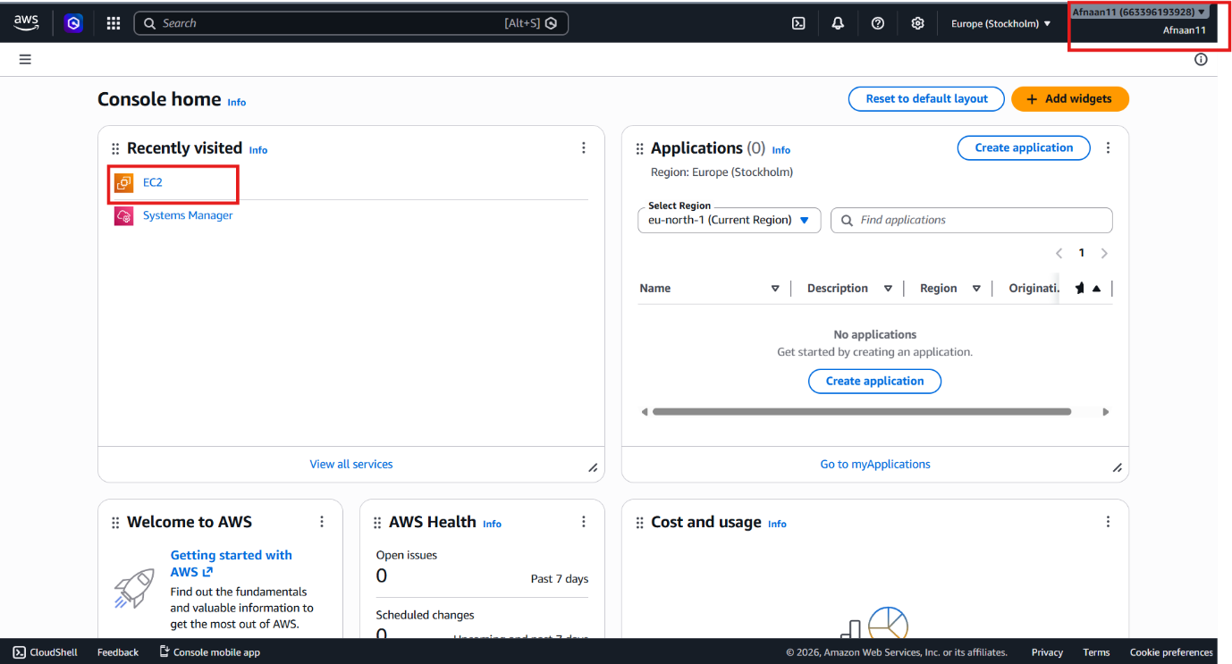
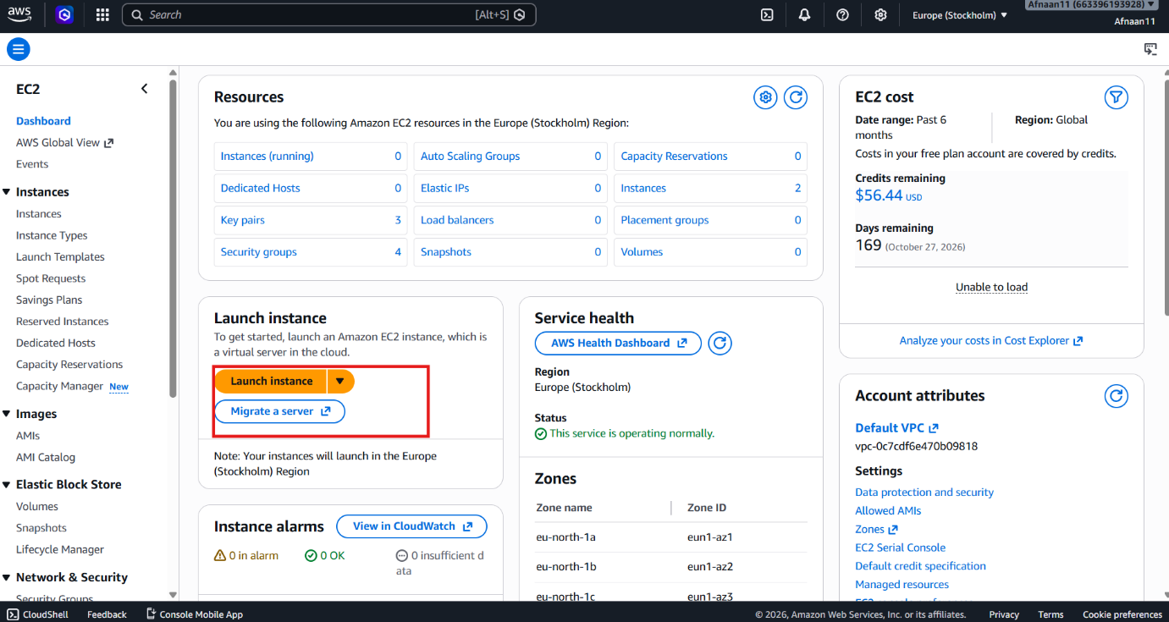


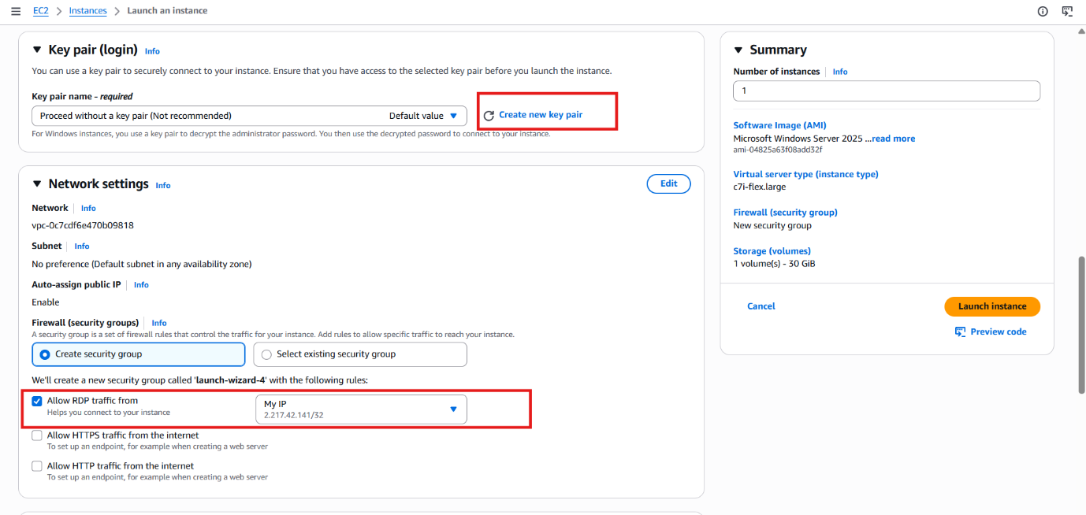
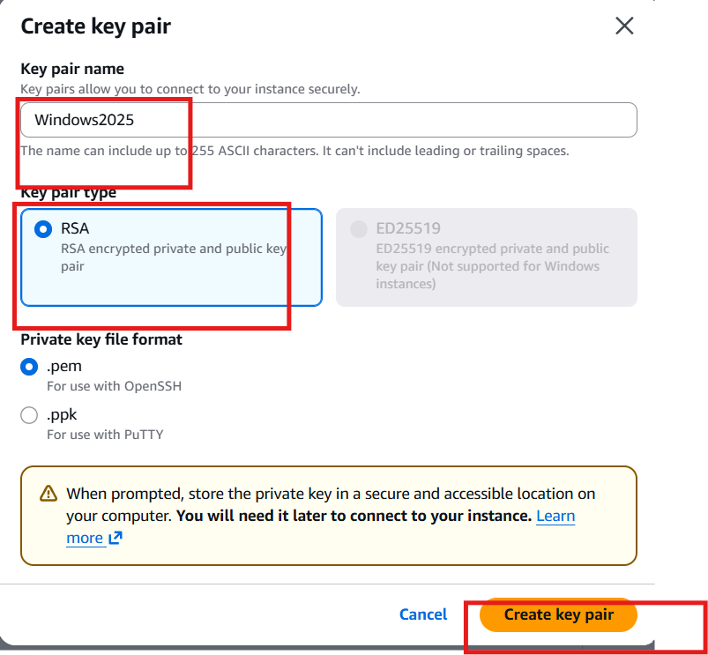
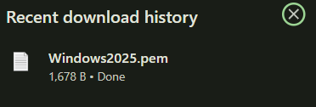
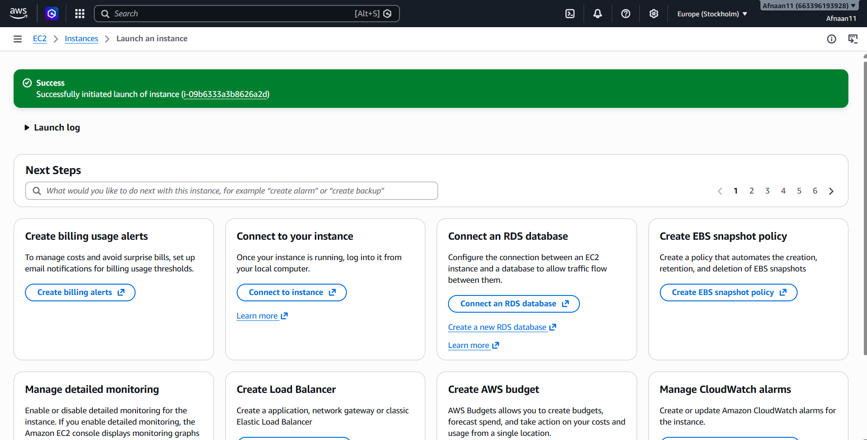
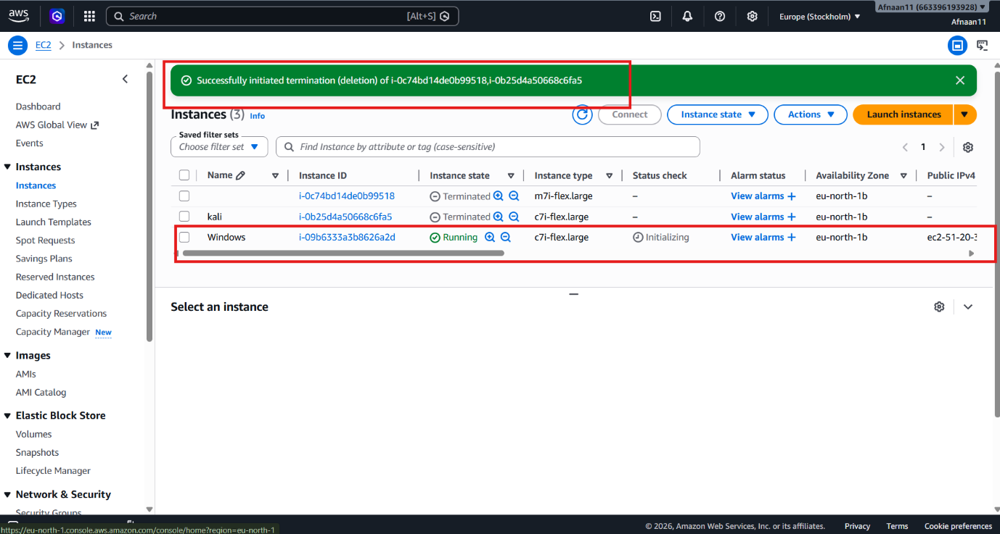

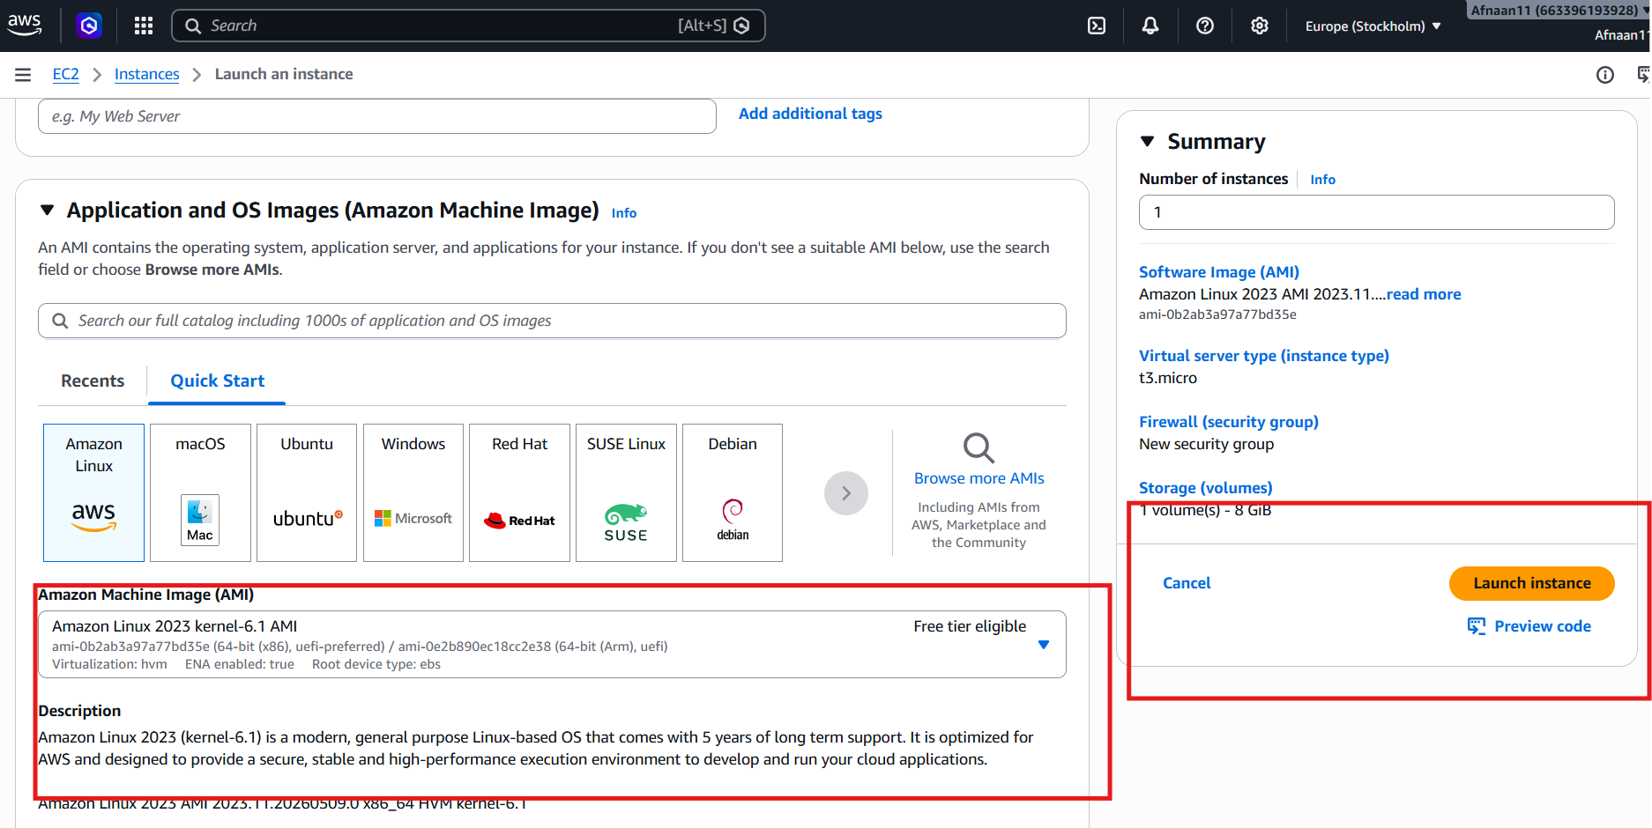
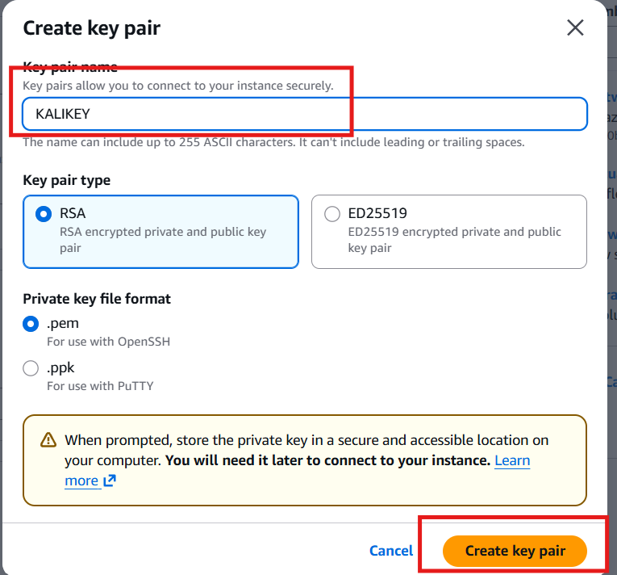
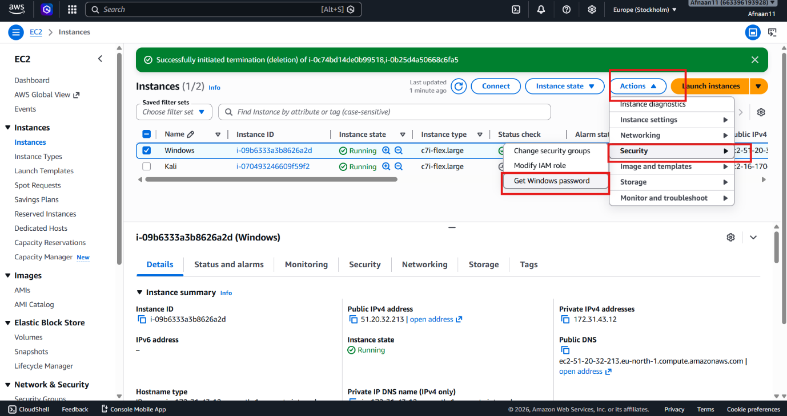
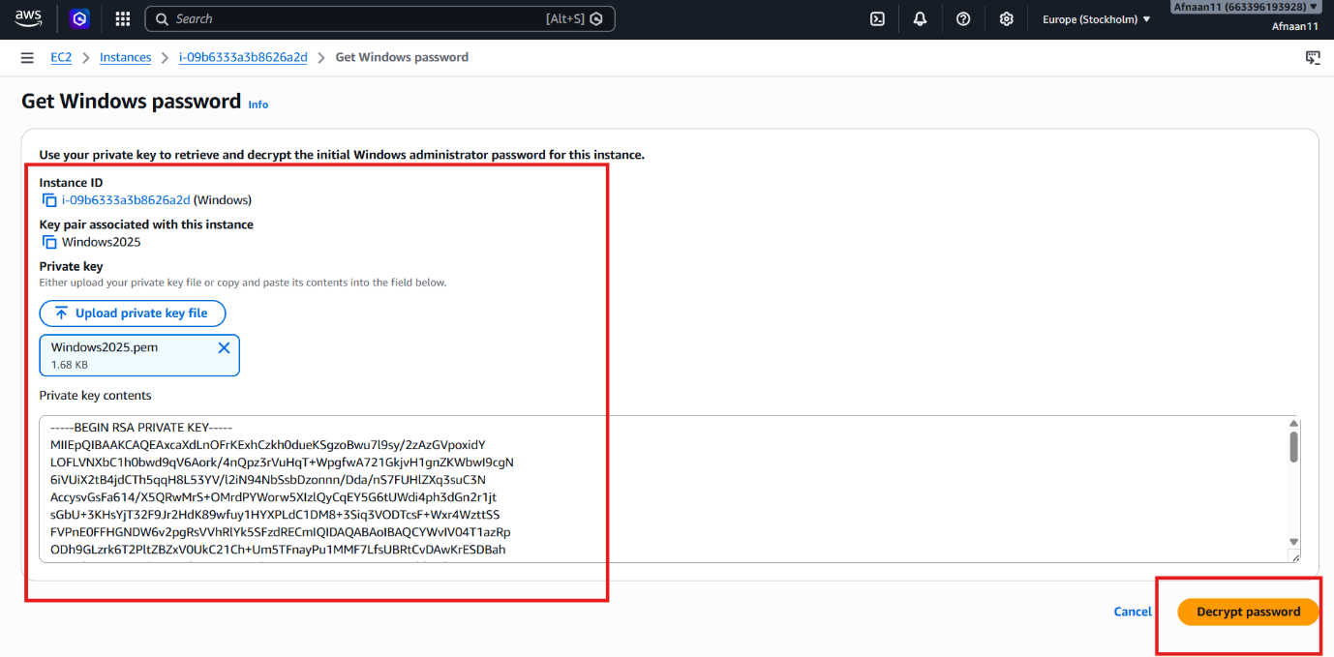
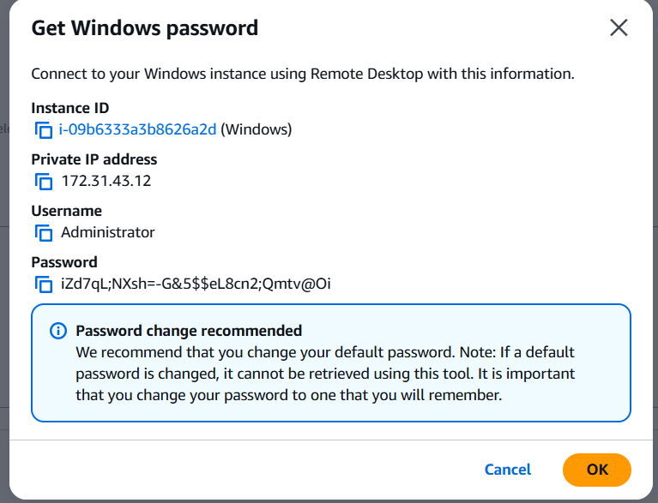
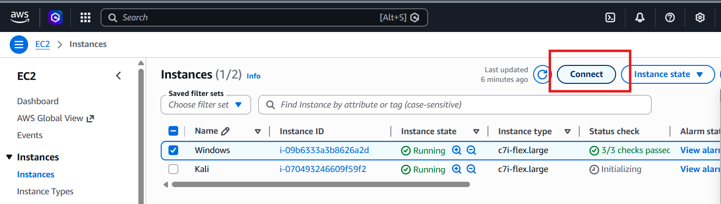
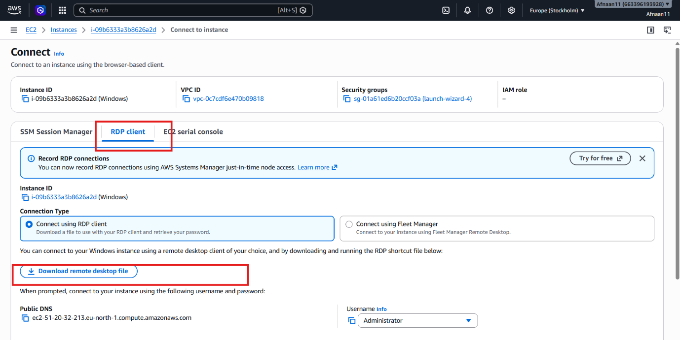
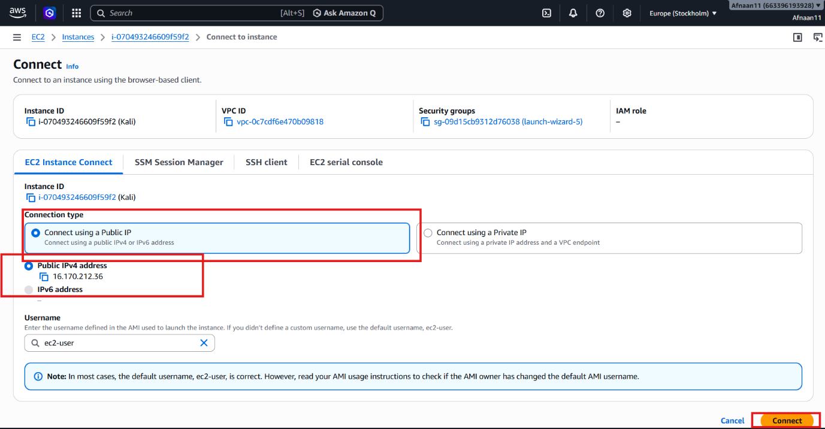
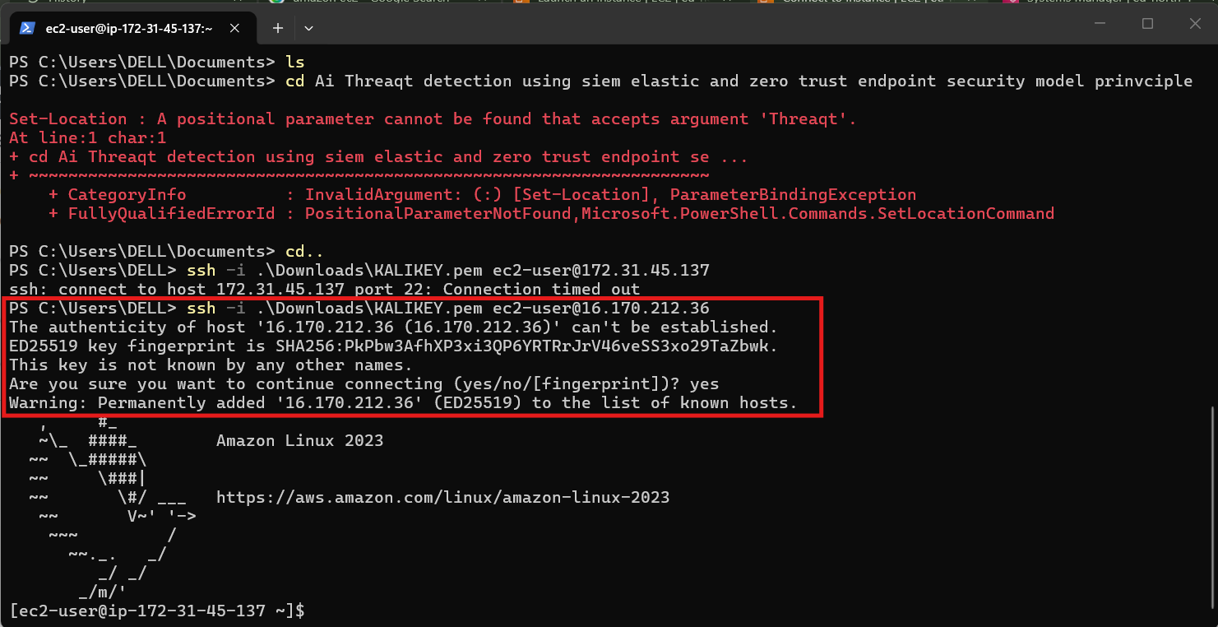
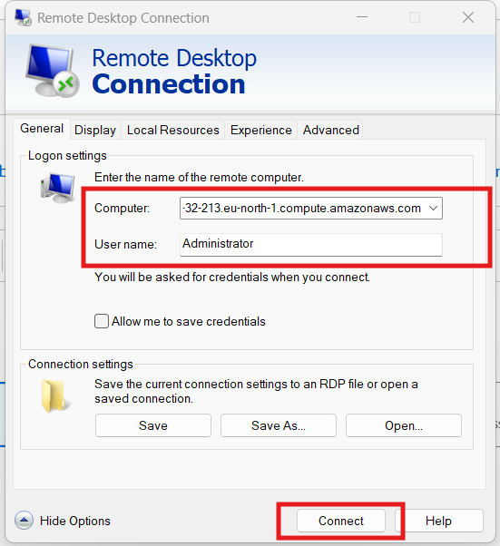
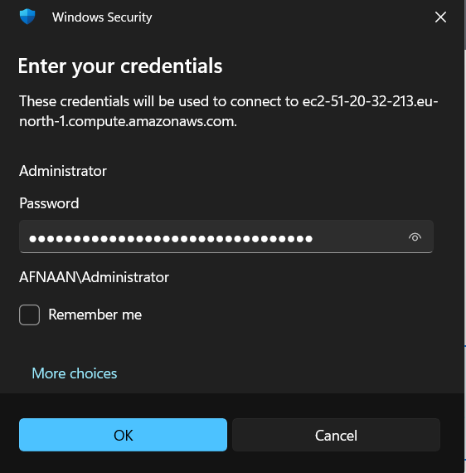

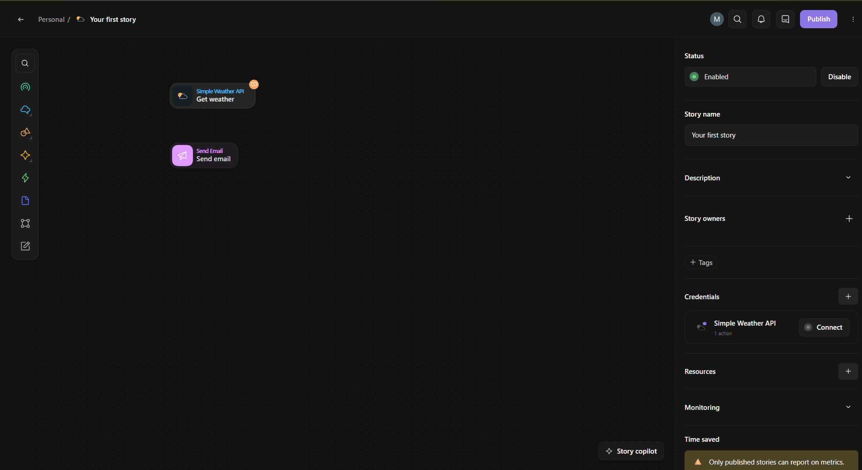
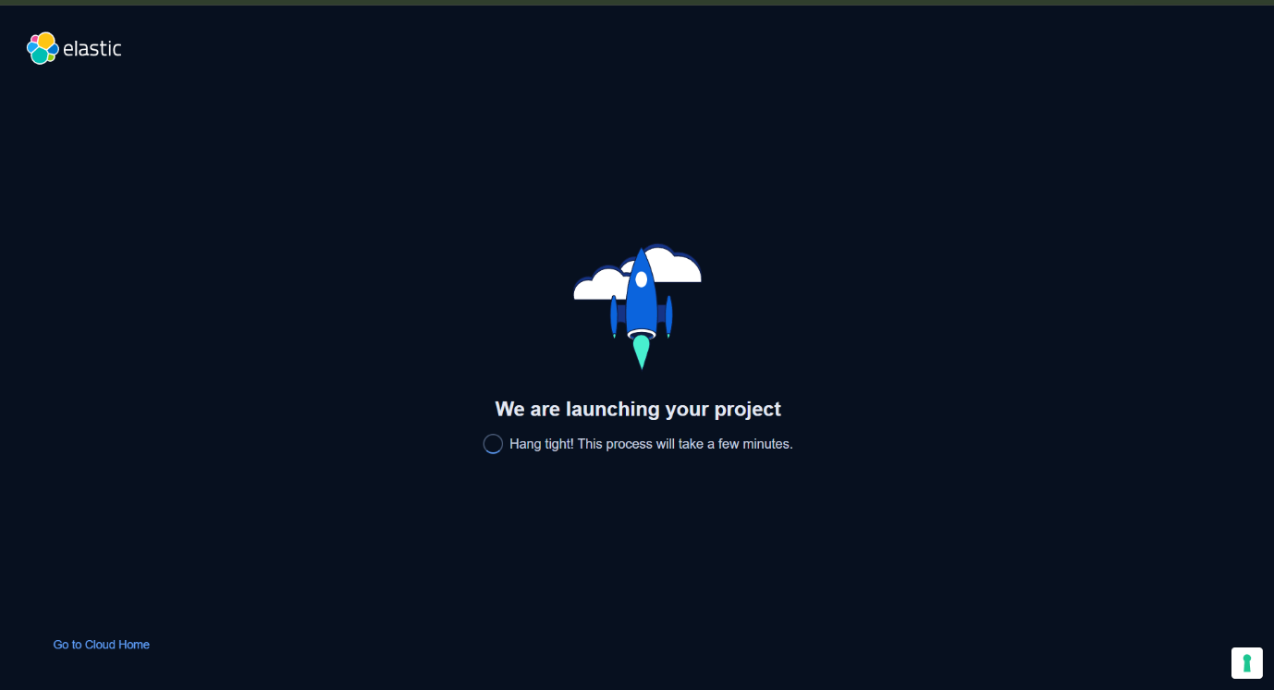
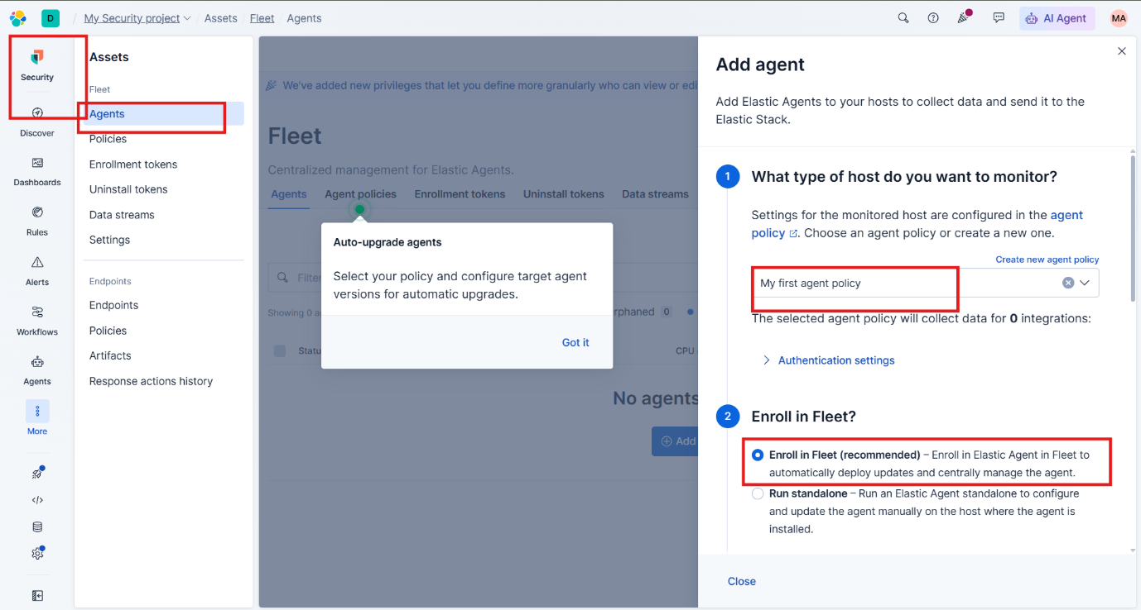

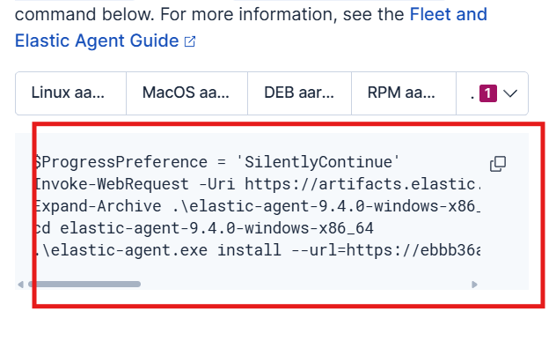
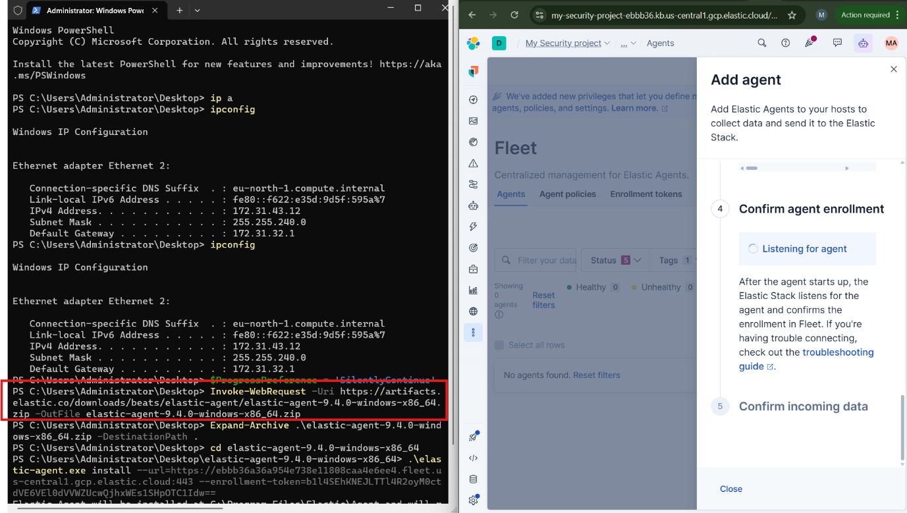
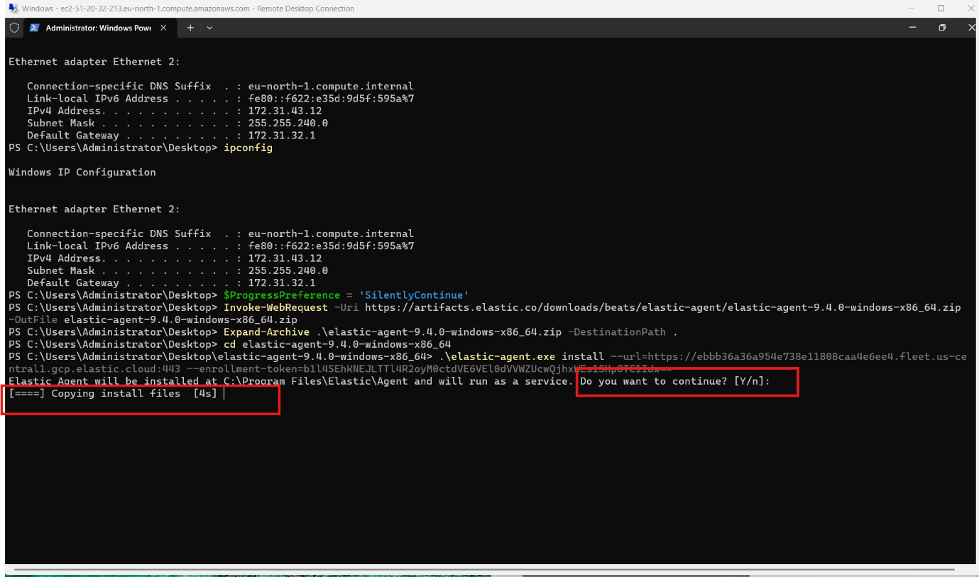
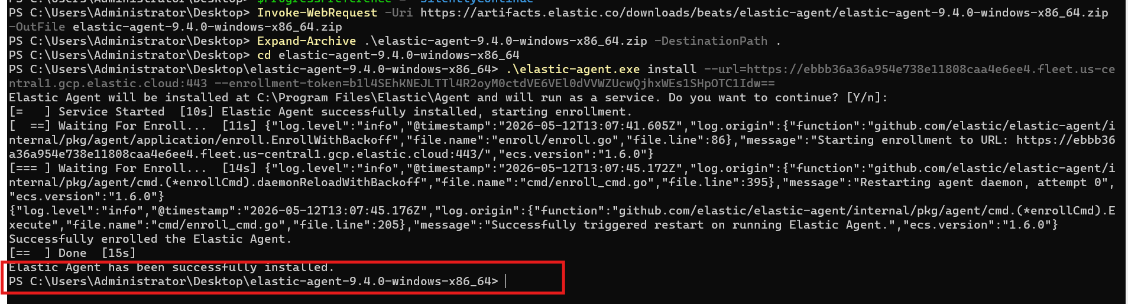
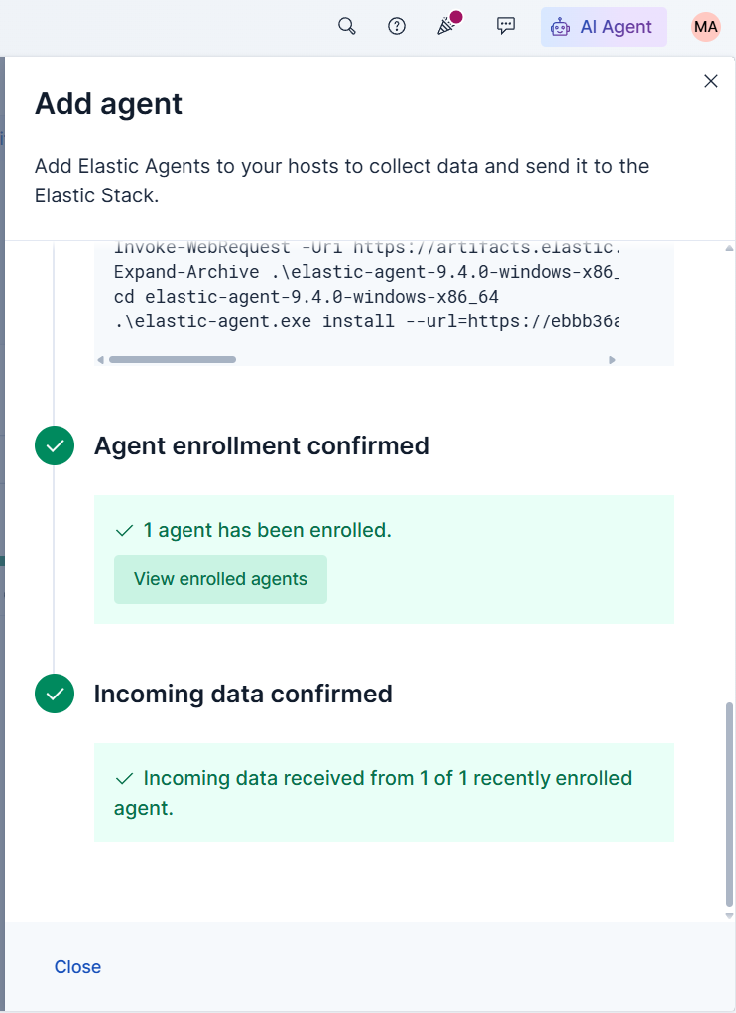
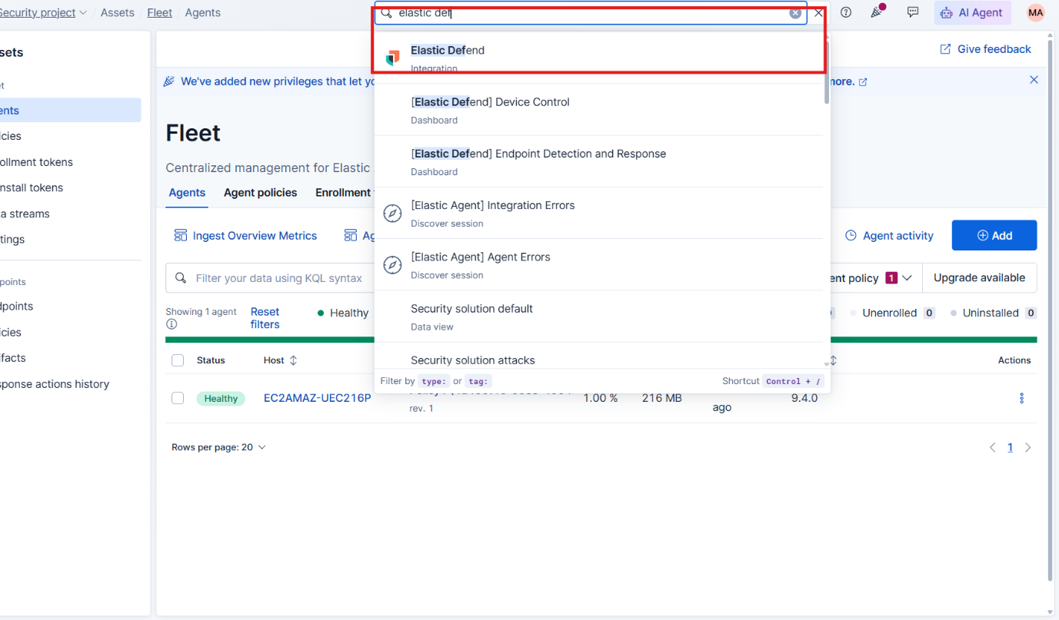
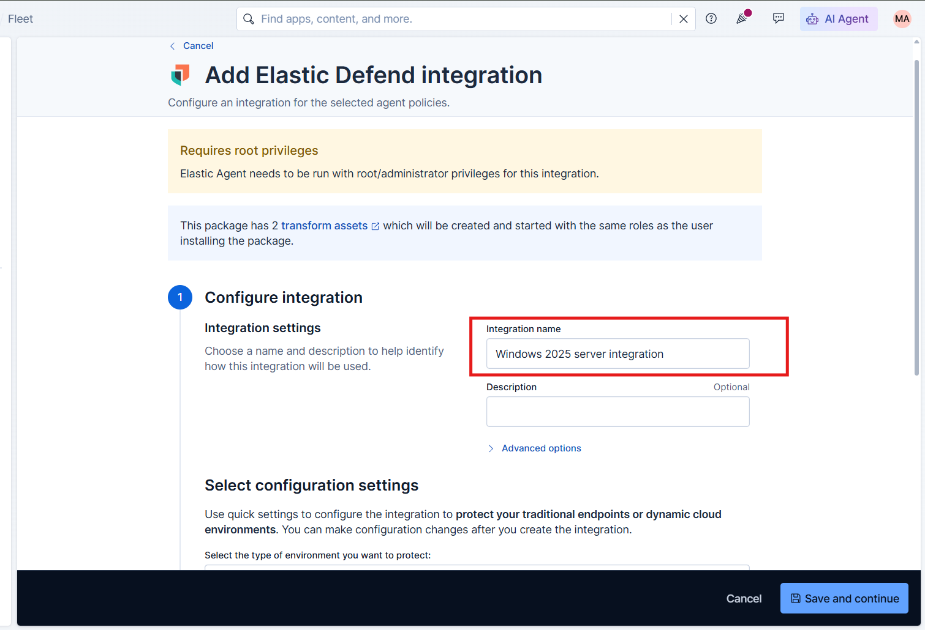
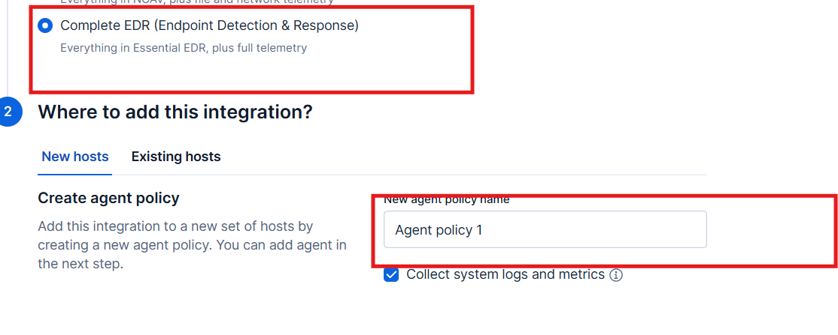


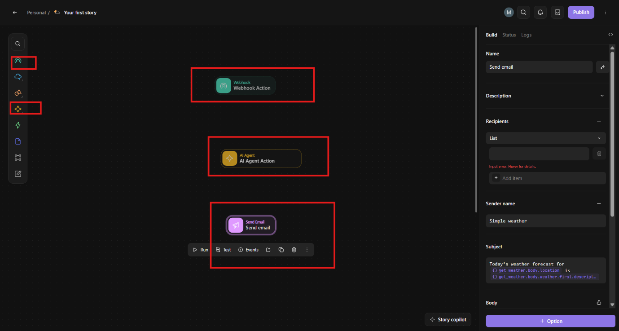
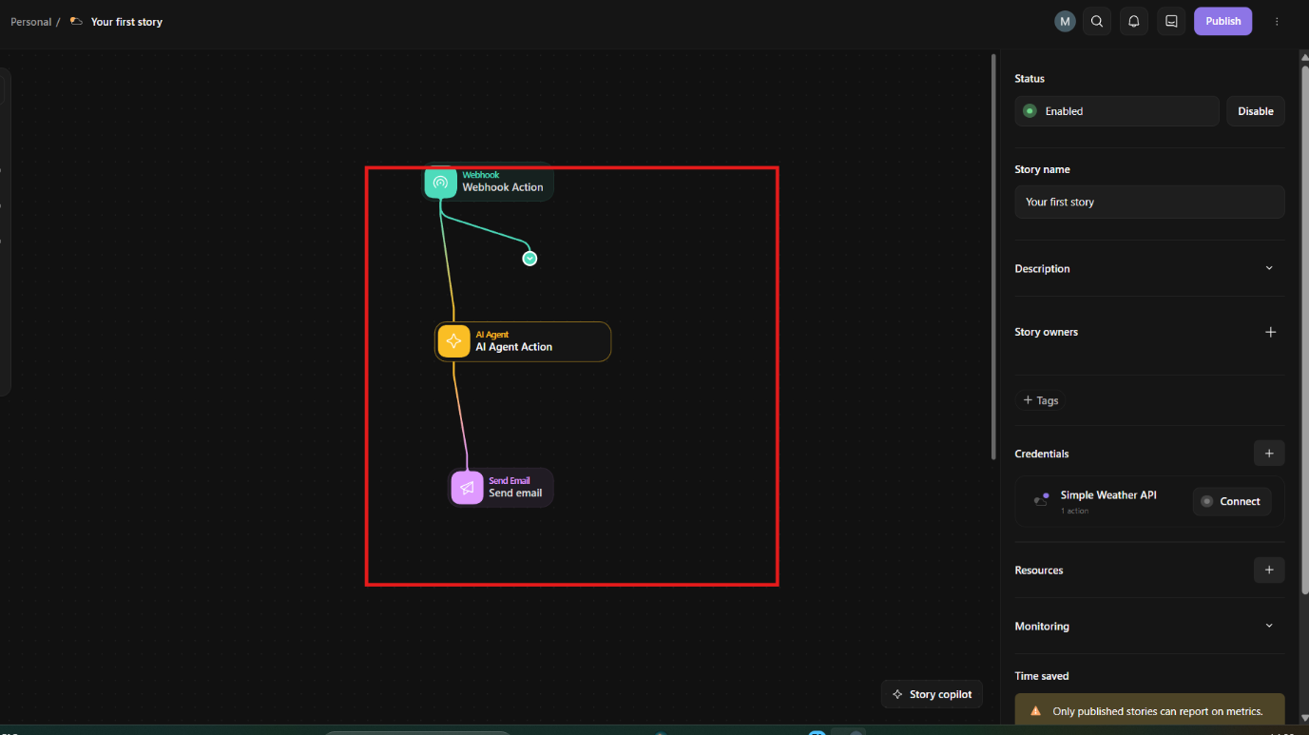
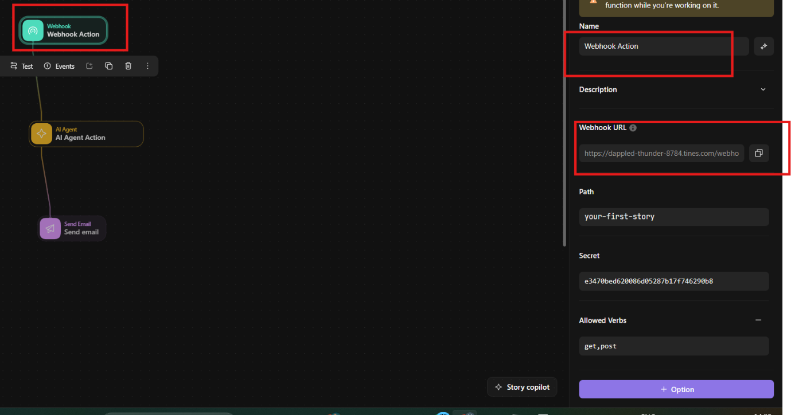
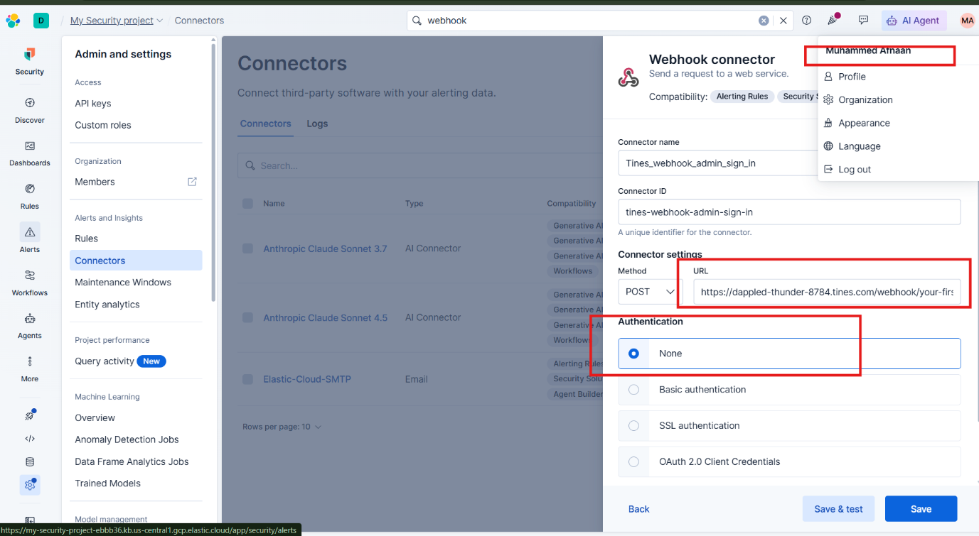
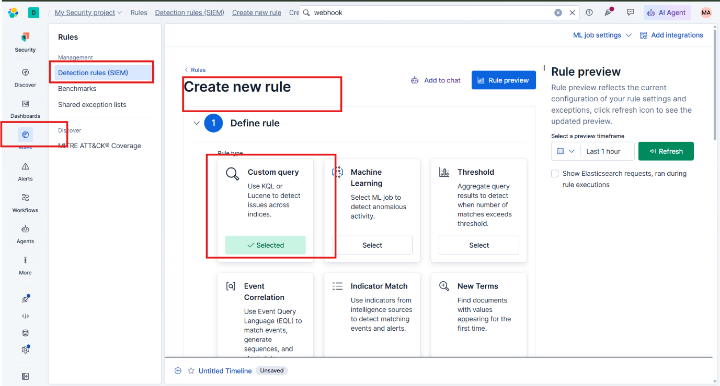
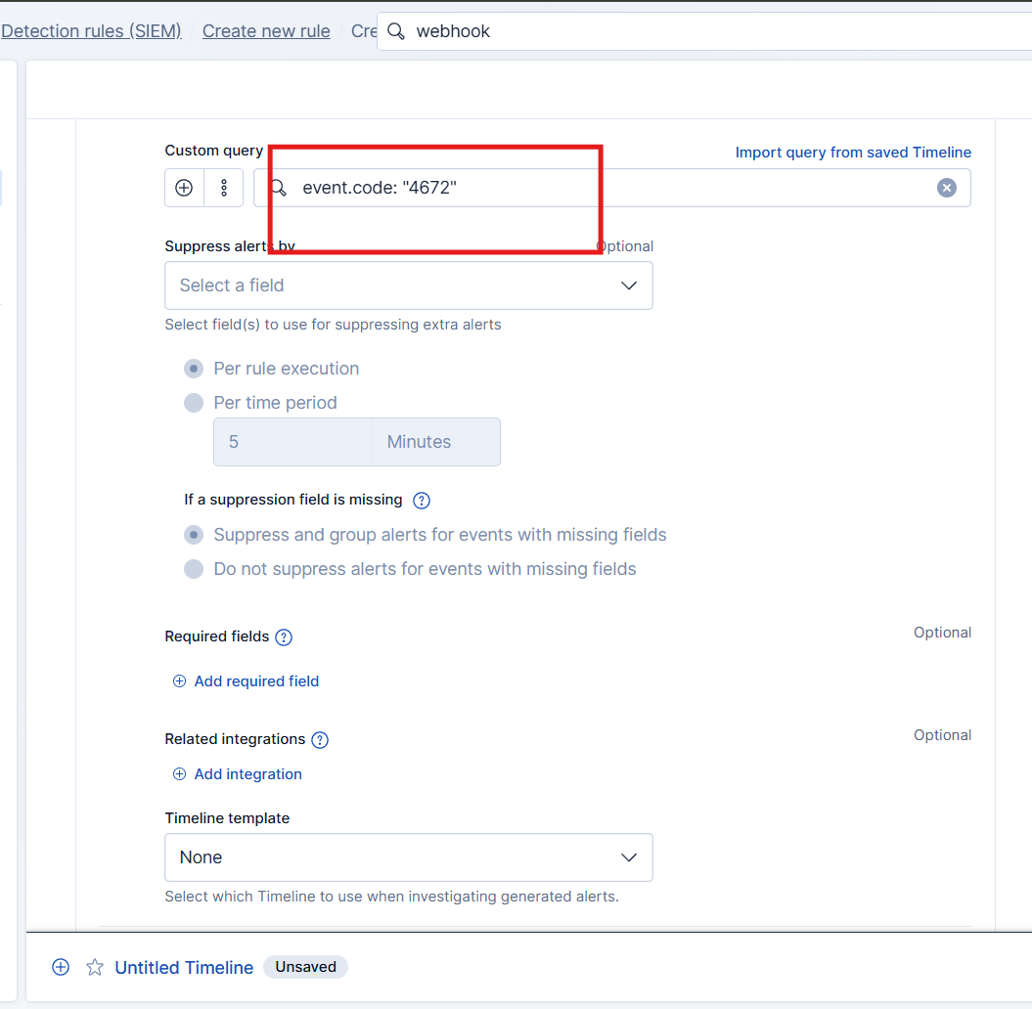
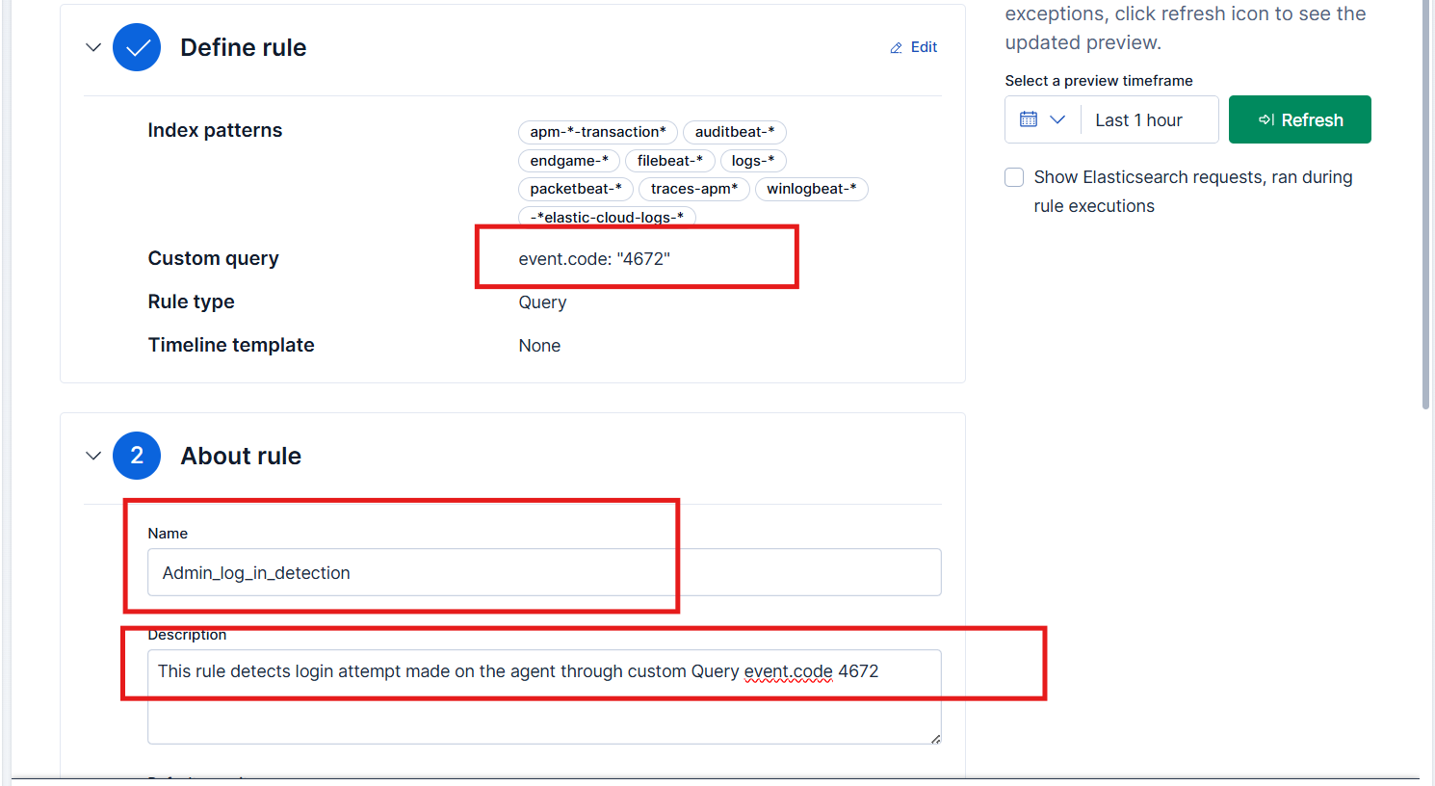
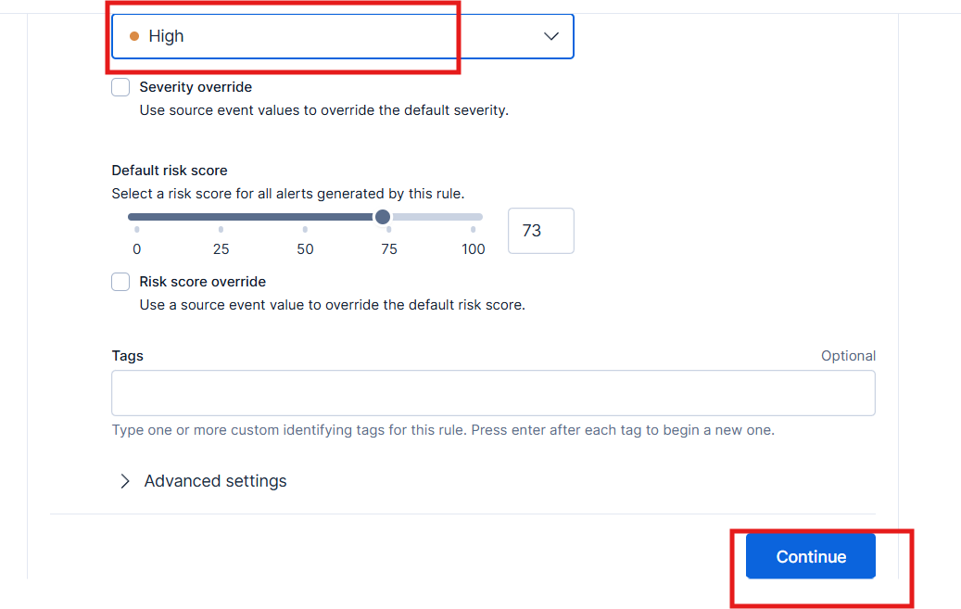
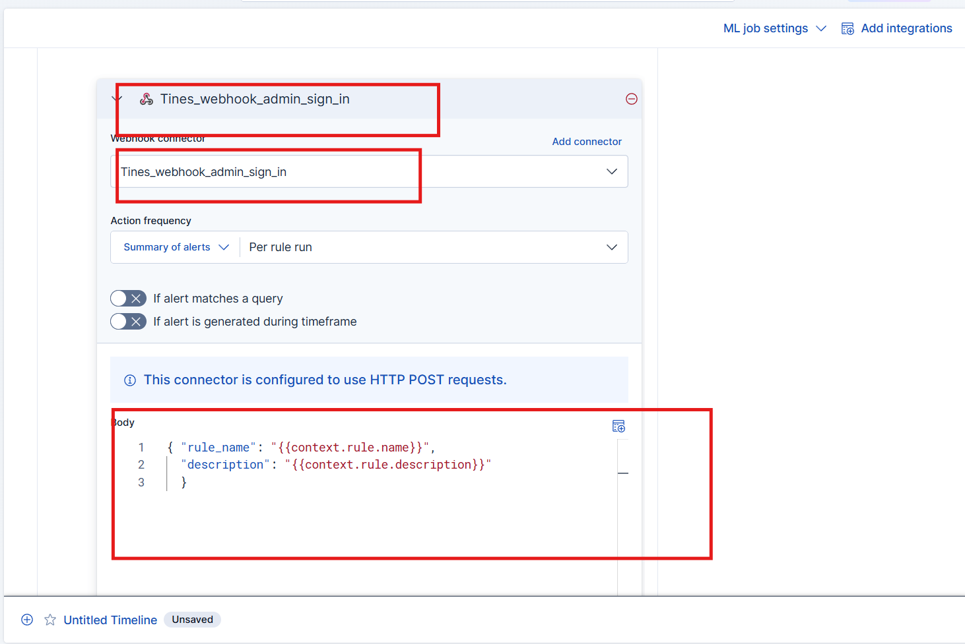
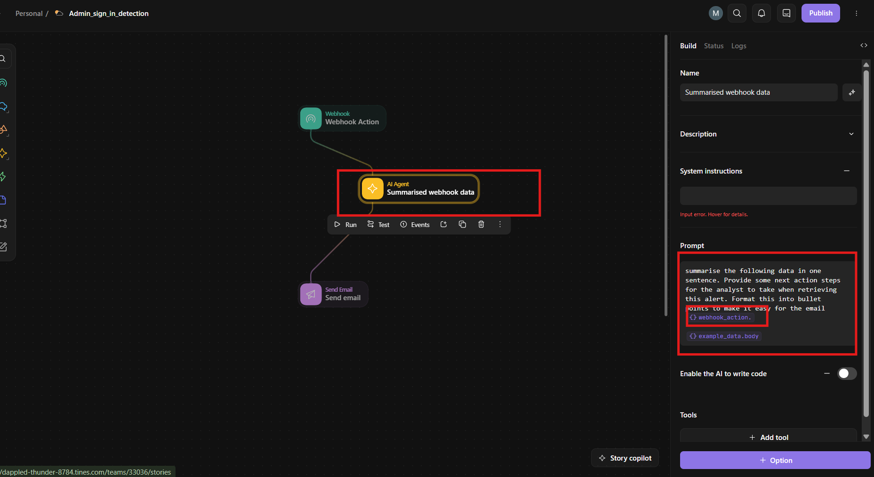
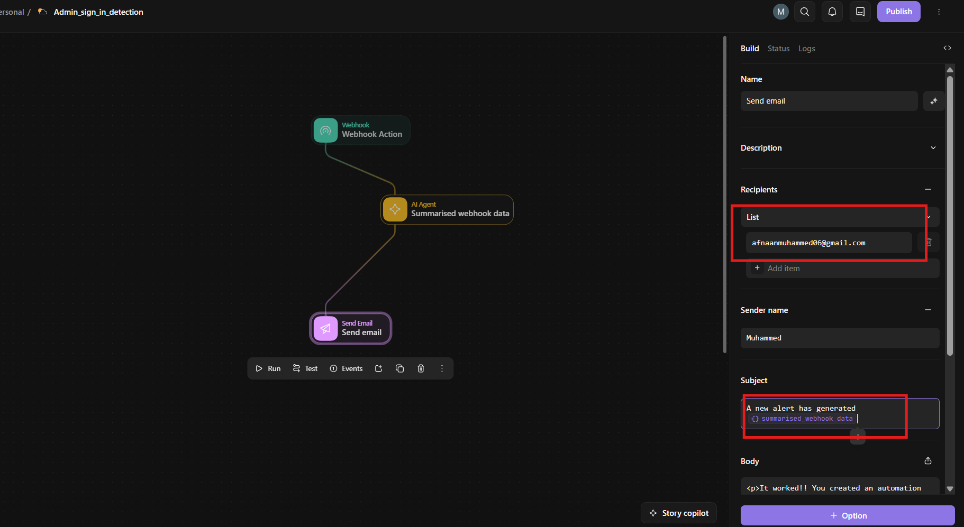
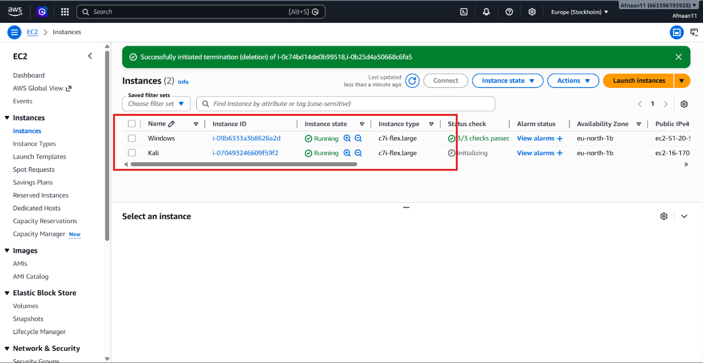

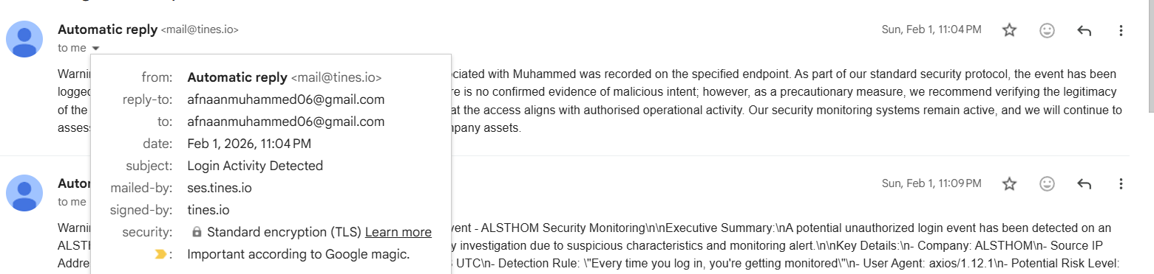
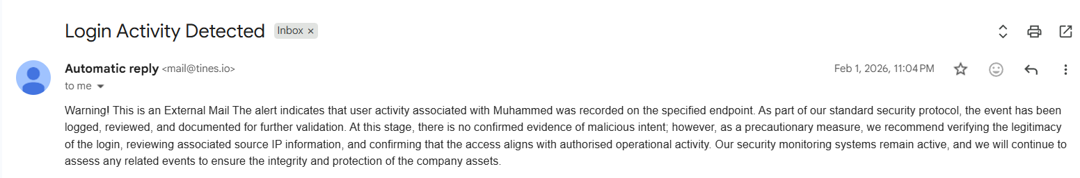

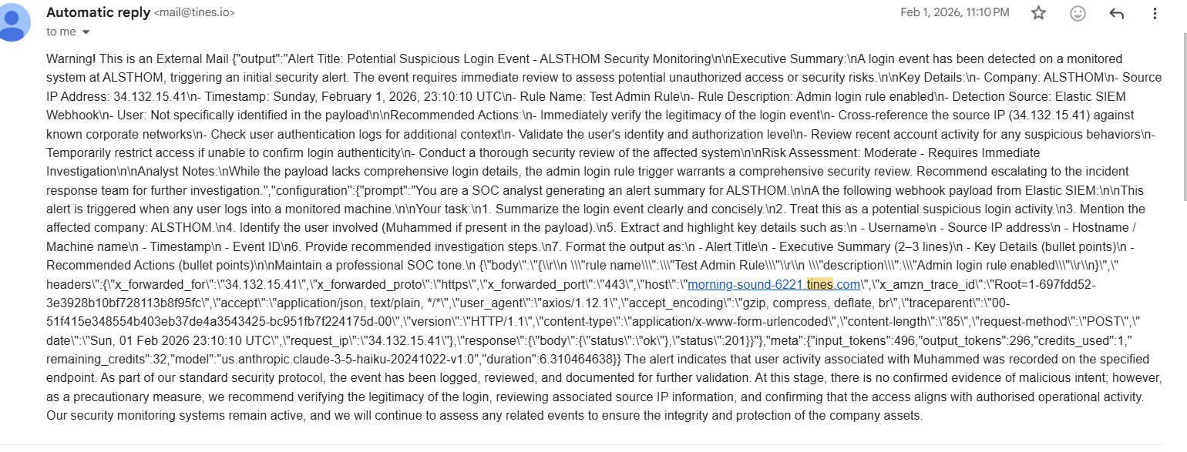

Chapter 8 Evaluation of the design

Discuss:
Strengths:
- Real SOC workflow
- Automation
- Cloud deployment
- AI integration
Limitations:
- Limited attack simulations
- Single endpoint
- Free trial limitations

Chapter 10 Critical Evaluation

10.1 Summary of Investigation

10.2 Findings Against Objectives

Objective | Achieved
Deploy AWS endpoint | Yes
Integrate Elastic | Yes
Create detection rule | Yes
AI automation | Yes
Zero Trust design | Partially implemented/Future extension

10.4 Personal Evaluation

References
Adriano Serckumecka, et al. CCE: A Cloud-Based SIEM Correlation Engine Built on Serverless Functions. 29 Sept. 2025, pp. 95–105, ieeexplore.ieee.org/stamp/stamp.jsp?tp=&arnumber=11360458, https://doi.org/10.1109/srds69199.2025.00022. Accessed 4 Mar. 2026.
Anupa, J., and K. Chandra Sekaran. “Cloud Workflow and Security: A Survey.” 2014 International Conference on Advances in Computing, Communications and Informatics (ICACCI), Sept. 2014, pp. 1598–1607, ieeexplore.ieee.org/document/6968496, https://doi.org/10.1109/icacci.2014.6968496. Accessed 7 Jan. 2026.
Breachsense. “Capital One Data Breach: How 106 Million Records Were Stolen.” Breachsense.com, 2026, www.breachsense.com/blog/capital-one-data-breach-case-study/.
Carlson, Teressa. The State of Cloud-Driven Transformation.
Chyun Horng Chi, et al. Intelligent-Based SIEM Security Email Alert. 23 Aug. 2023, https://doi.org/10.1109/icoict58202.2023.10262562.
Cinque, Marcello . “Challenges and Directions in Security Information and Event Management (SIEM) - IEEE Conference Publication.” Ieee.org, 2018, ieeexplore.ieee.org/stamp/stamp.jsp?tp=&arnumber=8539170.
FARZAAN. “IEEE Xplore Full-Text PDF”: Ieee.org, 2026, ieeexplore.ieee.org/stamp/stamp.jsp?tp=&arnumber=10979487. Accessed 25 Feb. 2026.
Guha, Debanksh, et al. A Practical Implementation of Zero Trust Architecture for Securing Web-Based Applications. 16 May 2025, pp. 1–6, https://doi.org/10.1109/assic64892.2025.11158196. Accessed 13 Oct. 2025.
Kim, Dasol, et al. “A Comparative Security Analysis of Storage-Integrated Web Applications in Heterogeneous Cloud Environments.” 2025 12th International Conference on Social Networks Analysis, Management and Security (SNAMS), 25 Nov. 2025, pp. 30–37, ieeexplore.ieee.org/stamp/stamp.jsp?tp=&arnumber=11391049, https://doi.org/10.1109/snams67467.2025.11391049. Accessed 4 Mar. 2026.
Kotenko, Igor, et al. “Aggregation of Elastic Stack Instruments for Collecting, Storing and Processing of Security Information and Events.” IEEE Xplore, 1 Aug. 2017, ieeexplore.ieee.org/abstract/document/8397627. Accessed 21 Aug. 2021.
Nagababu Garigipati, et al. A Multi-Layered Hybrid Security Algorithm Based on Integrity for the Cloud Computing Environment. 19 July 2023, https://doi.org/10.1109/icecaa58104.2023.10212405. Accessed 29 Jan. 2024.
Narasappa, Dharnisha. “Integrating Zero Trust Architecture with Automation and Analytics for Resilient Cybersecurity.” 2025 3rd International Conference on Data Science and Network Security (ICDSNS), 25 July 2025, pp. 1–6, https://doi.org/10.1109/icdsns65743.2025.11168551. Accessed 12 Jan. 2026.
Narayan, Yogendra, et al. Strengthening Network Security through the Implementation of AI-Driven Automated Incident Response Systems. 18 Sept. 2025, pp. 1–5, ieeexplore.ieee.org/document/11233253, https://doi.org/10.1109/icccnp63914.2025.11233253. Accessed 7 Jan. 2026.
Roy, Hannah. “Understanding Your Tines Deployment Options.” Tines.com, Tines, 15 Jan. 2026, www.tines.com/blog/understanding-your-tines-deployment-options/. Accessed 4 Mar. 2026.
SIMIN LI . “Design and Computational Modeling of an AI-Based Automated Cybersecurity Incident Response System.” Ieee.org, 2026, ieeexplore.ieee.org/stamp/stamp.jsp?tp=&arnumber=11145017. Accessed 2 Mar. 2026.
Sorn, Jacob, et al. Exploring the CAM4 Data Breach: Security Vulnerabilities and Response Strategies. 4 May 2024.
Sornalakshmi, K. “Detection of DoS Attack and Zero Day Threat with SIEM.” 2017 International Conference on Intelligent Computing and Control Systems (ICICCS), June 2017, https://doi.org/10.1109/iccons.2017.8250515. Accessed 19 May 2020.
Threatlocker. “Zero Trust Endpoint Security | ThreatLocker, Inc.” Www.threatlocker.com, www.threatlocker.com/.
University, Threatlocker. “Loading.” Docebosaas.com, 2026, threatlocker.docebosaas.com/learn. Accessed 7 Jan. 2026.
Wei, Yu Chih, and Tak Wai Yu. “Zero Trust Framework in Financial Sector: The Handling of Machine Learning Based Trust Management.” IEEE Xplore, 1 July 2023, ieeexplore.ieee.org/document/10226959.

Appendices

